SILVER HAKE FRAMEWORK ASSESSMENT

Part 1 – Data Inputs.

M.A. Showell and others….

The Fishery

The silver hake fishery has been conducted on the Scotian Shelf (North Atlantic Fisheries Organization Divs. 4VWX, Figure 1) since the mid-1960’s, primarily by the distant water fleets of Russia, Cuba and Japan in the early years. Prior to 1977, fishing on the Scotian Shelf was unrestricted in terms of area, mesh size and season. During this period, fishing was conducted over the entire shelf, and the use of trawl mesh as small as 40 mm was common. Following the extension of jurisdiction to 200 miles by coastal states in 1977, Canada implemented the Coastal Fisheries Protection Act, which restricted fishing for this species to the seaward side of the Small Mesh Gear Line (SMGL, Figure 1), west of 60º W longitude, with a minimum mesh size of 60 mm. On an experimental basis, a portion (4-6 vessels) of the fleet was allowed to fish landward of the SMGL during 1978 and 1979. From 1980 through 1983, fishing was permitted by condition of license in an eastern extension of the Silver Hake Box as far as 57º W longitude; from 1984 to present, this eastern extension has been restricted to 59º W longitude. In 1994, further restrictions were introduced to minimize incidental catches of cod, haddock and pollock in the silver hake fishery. These included a repositioning of the SMGL to prevent fishing in depths less than 190 m (Branton, 1998) and the use of a separator grate with 40 mm bar spacing in the lengthening piece of the trawl.

Foreign vessel participation in the silver hake fishery, either through national allocations or Canadian charter agreements, declined through the 1990’s, and ended in 2004.

Canadian fishing interests have engaged in experimental harvesting of this species since 1975, although until 1995 these efforts were developmental in nature (Showell and Cooper, 1997). From 1995 to present, a commercial fishery has been conducted by the Canadian tonnage class 3 (< 65’) mobile gear fleet in and around Emerald and LaHave basins (Figure 1). Concern was expressed over the harvesting of small fish in these inshore areas, and experimental evidence suggested a change to 55 mm square mesh would be effective in releasing small silver hake (Cooper, 1995). As a result, 55 mm square mesh, rather than the traditional 60 mm diamond, was made mandatory in 1999. Initially, a topside chafer was required to support the codend during haulback, as the tensile strength of the twine used to manufacture the square mesh was lower than that of traditional diamond mesh. It was recognized that gear configured in this manner had the potential to block the meshes, thus mitigating the benefits of the square mesh. To address this, a codend composed of stronger twine was designed, and from 2000 onwards topside chaffers have not been used in this fishery.

Nominal catches from this stock ranged from nearly 300,000 tons in 1973 to under 8,000 tons in 1994 (Table 1). Catches by the foreign fleet were generally high during the mid to late 1980’s, with catches in recent years much lower (Table 1, Figure 2). As the inshore Canadian fishery has developed, proportions of the catch harvested by the inshore (Basin) and offshore (Slope) fleet components have changed, and since 1998 the catch by the inshore fleet has exceeded that of the offshore (Figure 3). Recent catch locations by Canadian vessels 2008-2011, as well as as an example of foreign fishing locations are shown in Figure 4 (Pages 24-26).

Removals at Age AND Size and Weights-at-Age

While no foreign allocations of silver hake have been made since 1997, the fishery is conducted by two distinct fleets - Canadian flag vessels < 65’ fishing in or near to Emerald and LaHave basins, and Cuban flagged tonnage class 7 vessels fishing seaward of the SMGL line under charter arrangements with Canadian partners. Several changes to the SMGL, and numerous temporary exemptions have occurred since 1994 to accommodate the Cuban fleet in this area. Details of these changes can be found in Branton (1998).

Sampling for length composition and ageing material from silver hake directed trips from 2005 to 2008 was conducted by both Canadian at-sea observers, as well as Department of Fisheries and Oceans (DFO) and Industry shore samplers. The commercial removals at age were calculated using the standard Population Ecology Division Catch-at-Age application, unculled length frequency data and quarterly age/length keys, by sex. Regressions of lengths with weights from the Canadian July groundfish research vessel survey were used to calculate yearly alphas (intercepts) and betas (slopes) by sex (Table 2) used in the calculation of length frequency based commercial sample weights and commercial mean weight-at-age. In one case, first quarter foreign catches were added to those of the Canadian fleet as the catch was small and sampling was limited (Table 3). Results from 2003 to 2008 are presented in Table 4.

The removals at age for 1977-2004 were taken from the previous assessment (Showell et al., 2005) to provide estimates for the period 1977-2008 inclusive (Table 5).

The age groups on which the fishery is conducted have changed over time. Until the late 1980’s, most of the catch was ages 3 and 4 fish. From 1990 to 1998, the catch shifted to age 2 and 3 year olds, and since 1999 a high proportion of the catch has been age 1 fish (Figure 5, Figure 6). Since 1999, most of the catch of 1 and 2 year old fish have been taken by the Canadian fleet (Figure 7) fishing primarily in Emerald and LaHave basins.

Commercial mean weight-at-age was calculated for the same periods as the catch-at-age for each fleet, weighted by monthly catches, prior to 1999, and quarterly from 1999 onward. An aggregate mean weight-at-age was then calculated, weighting by the catches of each fleet. As has been noted in the past for this stock, commercial mean weight-at-age declined from 1977 to 1994, but has stayed relatively stable at a lower level in subsequent years (Figure 7, Table 4).

Research Vessel Surveys

A stratified random design groundfish research vessel (RV) survey has been conducted on the Scotian Shelf (Figure 8) from 1970 using three Canadian research vessels (A.T. Cameron, Lady Hammond, and the CCGS Alfred Needler). Based on an analysis of comparative fishing experiments by Fanning (1985) a conversion factor of 2.3 is applied to the abundance series prior to 1982 to account for the effect of vessel and gear changes between the A.T. Cameron and the other two vessels. The same conversion factor was used to adjust biomass estimates. No conversion factor is required between the Lady Hammond and the CCGS Alfred Needler for this period. The survey was conducted by the CCGS Teleost in 2004 and 2007. An analysis of comparative fishing experiments showed no conversion factor was required between the two vessels for silver hake (Fowler and Showell, 2009).

Silver hake found in the Bay of Fundy area likely represent a portion of the Gulf of Maine/Northern Georges Bank silver hake stock, rather than the Scotian Shelf stock (Showell, 1998). As was the case in the previous assessment of this resource, survey trends in both total numbers and biomass were therefore calculated for the Scotian Shelf portion of 4VWX only, excluding strata 484 through 495 (Figure 8).

Typical sampling locations for this survey are shown in Figure 9. Silver hake abundance and biomass estimates are presented in Figure 10. Recruitment estimates (abundance at age 1) are available from 1971 to 2011, and are presented in Figure 11.

An estimate of spawning stock biomass can be taken as the abundance of 2+ fish in the population. This information is presented in Figure12.

Numbers-at-age for the Scotian Shelf strata only are presented in Table 8.

Industry Survey

A standardized groundfish survey has been conducted in 4X by the Individual Transferable Quota (ITQ) mobile gear < 65’ fleet since 1995, with sampling since 1996 considered appropriate for abundance estimates. While this survey does not cover the entire stock area for silver hake it does cover areas in 4X that are not accessible to the Canadian July groundfish research vessel survey (Figure 13), and can provide an additional useful index of abundance, despite the relatively small number of years for which it has been conducted. The survey shows a declining trend in both numbers and biomass from 1999 to 2002, increased between 2002 and 2004, but dropped sharply in 2005 and has remained stable at a lower level subsequently (Figure 14).

Commercial Catch Rates

When the foreign fleet was active at a catch rate series was developed incorporating month, country and NAFO area. Despite the usual suspicision of catch rate data, this series was though to be acceptable because the same vessels, often with th same captains, fished the same limited area. Technological change was also very limited in this fleet. This CPUE series was discontinued when the foreign fleet were no longer permitted to fish in Canadian waters. (Figure 15)

As in the previous assessment Showell et al., 2010), an analyses of deviance using a generalized linear modeling approach with S-Plus 6.1 was conducted to determine magnitudes of influence of year, month and area on commercial catch rates of Canadian silver hake fishers. Catch–per-unit-effort (CPUE) was calculated as sub-trip tons per fishing day, with the model output predicted catch rates on an annual basis. (Figure 16).

The results of this analysis were not supported by Industry, due to concerns that assigning experience by fishing vessels failed to capture the required information, since captains were changing.

Relative FISHING MORTALITY (RELATIVE F)

Relative fishing mortality can be calculated as the ratio of the commercial catch over the stratified total biomass estimates from the July RV survey (Figure 17). This statistic does not give an absolute estimate of the true fishing mortality, but trends over time can be useful in examining exploitation patterns. .

EGG and LARVAL DISTRIBUTION

Data are available on the distribution of silver hake eggs and larva, from 1980 to 1982, through the SSIP program database. These are presented in Figures 18 and 19.

Information on the distribution of ripe and running silver hake from 1970 to 2001 is presented in Figure 20.

Biological Indices

Previous analysis (Showell et al., 2005) has shown both condition (weight for given length, males and females averaged) (Figure 21), and mean length-at-age (Table 6a and b, Figure 22) to have declined from 1971 to 1995, with the two factors combining to produce very low mean weights-at-age relative to the early period in the time series (Table 6a and b, Figure 23).

Ecosystem Considerations

Although a small mesh fishery, the Scotian Shelf silver hake activity is restricted to deeper water, in the inshore basins or off the edge of the shelf, which limits bycatch. In addition, a separator grate that restricts the catch of larger fish is mandatory.

DFO at-sea fishery observers are routinely deployed to the silver hake fleet, to monitor catches and discards of the directed species, as well as bycatch. While observer coverage levels can be calculated in several ways (% trips, % days fished), the proportion of the main species observed to landed catches is most representative. Using this method, observer coverage on the silver hake fleet in recent years (2000 – 2009) ranged from approximately 2% to 20%, with an average of 9%.

Based on observer records (Table 13), 96% of the catch silver hake trips was of the directed species. Discarding of silver hake was minimal, at less than 0.1 of the total catch. Red hake, herring and dogfish were the most common bycatch species, at 0.9, 0.8 and 0.4%, respectively. Other species of possible concern are a rare bycatch, such as basking shark (0.1%) and pilot whales (0.02%).

TABLES

Table 1: Nominal catches (mt) for 4VWX silver hake 1970-2011.

Country | 1970 | 1971 | 1972 | 1973 | 1974 | 1975 | 1976 | 1977 | 1978 | 1979 | 1980 | 1981 | 1982
Bulgaria | 0 | 0 | 0 | 0 | 0 | 1722 | 3088 | 862 | 606 | 4639 | 817 | 0 | 0
Canada | 0 | 0 | 0 | 0 | 11 | 101 | 26 | 10 | 26 | 13 | 104 | 6 | 38
Cuba | 0 | 0 | 201 | 0 | 0 | 1724 | 12572 | 1847 | 3436 | 1798 | 2287 | 642 | 11969
France | 0 | 0 | 0 | 0 | 0 | 0 | 0 | 15 | 0 | 0 | 0 | 0 | 2
FRG | 0 | 0 | 10 | 0 | 296 | 106 | 97 | 684 | 0 | 0 | 0 | 0 | 0
GDR | 0 | 0 | 0 | 0 | 0 | 0 | 0 | 0 | 3 | 0 | 0 | 0 | 0
Ireland | 0 | 0 | 0 | 0 | 0 | 108 | 106 | 0 | 0 | 9 | 0 | 0 | 0
Italy | 0 | 0 | 0 | 0 | 0 | 0 | 0 | 38 | 106 | 5 | 0 | 541 | 37
Japan | 129 | 8 | 63 | 88 | 67 | 54 | 78 | 19 | 161 | 219 | 239 | 120 | 937
Poland | 0 | 0 | 0 | 0 | 0 | 0 | 0 | 295 | 2 | 0 | 0 | 1 | 31
Portugal | 0 | 0 | 0 | 0 | 0 | 0 | 0 | 0 | 0 | 0 | 56 | 2044 | 2
Romania | 0 | 0 | 0 | 0 | 0 | 0 | 0 | 10 | 0 | 1 | 0 | 0 | 0
Spain | 0 | 15 | 0 | 0 | 0 | 6 | 0 | 0 | 2 | 0 | 40 | 0 | 0
USA | 0 | 1 | 1 | 1 | 1 | 7 | 1 | 14 | 0 | 0 | 0 | 3 | 2
USSR | 168916 | 128633 | 113774 | 298533 | 95371 | 112566 | 81216 | 33301 | 44062 | 45076 | 40982 | 41243 | 47261
Total | 169045 | 128657 | 114048 | 298621 | 95745 | 116394 | 97184 | 37095 | 48404 | 51760 | 44525 | 44600 | 60251

Table 1 (continued): Nominal catches (mt) for 4VWX silver hake 1970-2009.

Country | 1983 | 1984 | 1985 | 1986 | 1987 | 1988 | 1989 | 1990 | 1991 | 1992 | 1993 | 1994 | 1995
Bulgaria | 0 | 0 | 0 | 0 | 0 | 0 | 0 | 88 | 0 | 0 | 0 | 0 | 0
Canada | 15 | 10 | 2 | 9 | 13 | 9 | 337 | 10 | 34 | 4 | 73 | 57 | 300¹
Cuba | 7418 | 14496 | 17683 | 16041 | 20219 | 9016 | 14541 | 13888 | 23708 | 16528 | 22018 | 7788 | 16835
France | 0 | 0 | 0 | 0 | 0 | 0 | 0 | 0 | 0 | 0 | 0 | 0 | 0
FRG | 0 | 0 | 0 | 0 | 0 | 0 | 0 | 0 | 0 | 0 | 0 | 0 | 0
GDR | 0 | 93 | 0 | 0 | 0 | 0 | 0 | 0 | 0 | 0 | 0 | 0 | 0
Ireland | 0 | 0 | 0 | 0 | 0 | 0 | 0 | 0 | 0 | 0 | 0 | 0 | 0
Italy | 2² | 0 | 0 | 0 | 0 | 0 | 0 | 0 | 0 | 0 | 0 | 0 | 0
Japan | 649 | 530 | 120 | 66 | 144 | 0 | 194 | 315 | 781 | 547 | 0 | 0 | 0
Poland | 0 | 0 | 0 | 0 | 0 | 0 | 0 | 0 | 0 | 0 | 0 | 0 | 0
Portugal | 378 | 1714 | 1338 | 0 | 0 | 0 | 0 | 0 | 0 | 0 | 0 | 0 | 0
Romania | 0 | 0 | 0 | 0 | 0 | 0 | 0 | 0 | 0 | 0 | 0 | 0 | 0
Spain | 0 | 0 | 0 | 0 | 0 | 0 | 0 | 0 | 0 | 0 | 0 | 0 | 0
USA | 0 | 0 | 0 | 1 | 0 | 0 |  | 0 | 0 | 0 | 0 | 0 | 0
USSR | 27377 | 57423 | 56337 | 66571 | 41329 | 65349 | 72917 | 55429 | 40786 | 14716 | 7139 | 0 | 0
Total | 35839 | 74266 | 75480 | 82688 | 61705 | 74374 | 87989 | 69730 | 65309 | 31795 | 29230 | 7845 | 17835
Table 1(continued): Nominal catches (mt) for 4VWX silver hake 1970-2009.

Country | 1996 | 1997 | 1998 | 1999* | 2000** | 2001 | 2002 | 2003 | 2004 | 2005 | 2006 | 2007 | 2008
Bulgaria | 0 | 0 | 0 | 0 | 0 | 0 | 0 | 0 | 0 | 0 | 0 | 0 | 0
Canada | 3473 | 4203 | 9979 | 16700 | 12900 | 18000 | 16700 | 12122 | 12911 | 11799 | 12258 | 12953 | 12055
Cuba | 21773 | 11961 | 6083 | 0 | 0 | 0 | 0 | 0 | 0 | 0 | 0 | 0 | 0
France | 0 | 0 | 0 | 0 | 0 | 0 | 0 | 2 | 0 | 0 | 0 | 0 | 0
FRG | 0 | 0 | 0 | 0 | 0 | 0 | 0 | 0 | 0 | 0 | 0 | 0 | 0
GDR | 0 | 0 | 0 | 0 | 0 | 0 | 0 | 0 | 0 | 0 | 0 | 0 | 0
Ireland | 0 | 0 | 0 | 0 | 0 | 0 | 0 | 0 | 0 | 0 | 0 | 0 | 0
Italy | 0 | 0 | 0 | 0 | 0 | 0 | 0 | 0 | 0 | 0 | 0 | 0 | 0
Japan | 0 | 0 | 0 | 0 | 0 | 0 | 0 | 0 | 0 | 0 | 0 | 0 | 0
Poland | 0 | 0 | 0 | 0 | 0 | 0 | 0 | 0 | 0 | 0 | 0 | 0 | 0
Portugal | 0 | 0 | 0 | 0 | 0 | 0 | 0 | 0 | 0 | 0 | 0 | 0 | 0
Romania | 0 | 0 | 0 | 0 | 0 | 0 | 0 | 0 | 0 | 0 | 0 | 0 | 0
Spain | 0 | 0 | 0 | 0 | 0 | 0 | 0 | 0 | 0 | 0 | 0 | 0 | 0
USA | 0 | 0 | 0 | 0 | 0 | 0 | 0 | 0 | 0 | 0 | 0 | 0 | 0
USSR | 669 | 0 | 168 | 0 | 0 | 0 | 0 | 666 | 0 | 0 | 0 | 0 | 0
Total | 25927 | 16,164 | 16062 | 16700 | 12900 | 18000 | 16700 | 12790 | 12911 | 11799 | 12258 | 12953 | 12055

Table 1(continued): Nominal catches (mt) for 4VWX silver hake 1970-2009.

Country | 2009 | 2010 | 2011
Bulgaria | 0 | 0 | 0
Canada | 10330 | 6546 | 9231
Cuba | 0 | 0 | 0
France | 0 | 0 | 0
FRG | 0 | 0 | 0
GDR | 0 | 0 | 0
Ireland | 0 | 0 | 0
Italy | 0 | 0 | 0
Japan | 0 | 0 | 0
Poland | 0 | 0 | 0
Portugal | 0 | 0 | 0
Romania | 0 | 0 | 0
Spain | 0 | 0 | 0
USA | 0 | 0 | 0
USSR | 669 | 0 | 168
Total | 25927 | 16,164 | 16062

Table 3. Sampling history for silver hake (1999 - 2011).

Year | Quarter | Keys | # Samples | # Measured | # Aged | Catch (t)
1999 | 1 | Domestic | 51 | 11684 | 240 | 974
 |  | Foreign | 102 | 22044 | 145 | 1374
 | Total |  | 153 | 33728 | 385 | 2348
 | 2 | Domestic | 126 | 26229 | 323 | 4845
 |  | Foreign | 301 | 72564 | 296 | 3080
 | Total |  | 427 | 98793 | 619 | 7925
 | 3 | Domestic | 40 | 9101 | 240 | 2336
 |  | Foreign | 52 | 11381 | 86 | 383
 | Total |  | 92 | 20482 | 326 | 2719
 | 4 | Domestic | 16 | 3377 | 162 | 3659
 |  | Foreign | 12 | 2691 | 58 | 50
 | Total |  | 28 | 6068 | 220 | 3709
Total |  |  | 700 | 159071 | 1550 | 16701
2000 | 1 | Domestic | 90 | 19155 | 95 | 3177
 |  | Foreign | 110 | 24456 | 89 | 546
 | Total |  | 200 | 43611 | 184 | 3723
 | 2 | Domestic | 96 | 17040 | 114 | 3950
 |  | Foreign | 71 | 15981 | 70 | 486
 | Total |  | 167 | 33021 | 184 | 4436
 | 3 | Domestic | 87 | 18406 | 163 | 1560
 |  | Foreign | 47 | 10185 | 29 | 216
 | Total |  | 134 | 28591 | 192 | 1776
 | 4 | Domestic | 43 | 8534 | 115 | 2966
 |  | Foreign | --- | --- | --- | ---
 | Total |  | 43 | 8534 | 115 | 2966
Total |  |  | 544 | 113757 | 675 | 12901
2001 | 1 | Domestic | 52 | 9974 | 173 | 3886
 |  | Foreign | 16 | 3474 | 56 | 126
 | Total |  | 68 | 13448 | 229 | 4012
 | 2 | Domestic | 100 | 18584 | 205 | 5926
 |  | Foreign | 120 | 25793 | 133 | 1651
 | Total |  | 220 | 44377 | 338 | 7577
 | 3 | Domestic | 34 | 6326 | 123 | 2526
 |  | Foreign | 17 | 3633 | 33 | 194
 | Total |  | 51 | 9959 | 156 | 2720
 | 4 | Domestic | 39 | 6842 | 169 | 3691
 |  | Foreign | --- | --- | --- | ---
 | Total |  | 39 | 6842 | 169 | 3691
Total |  |  | 378 | 74626 | 892 | 18000
2002 | 1 | Domestic | 96 | 17186 | 200 | 3399
 |  | Foreign | --- | --- | --- | (650 - added to Q2)
 | Total |  | 96 | 17186 | 200 | 3399
 | 2 | Domestic | 53 | 9306 | 157 | 4074
 |  | Foreign | 82 | 17035 | 113 | 2556 (1906+650)
 | Total |  | 135 | 26341 | 270 | 6630
 | 3 | Domestic | 44 | 8149 | 126 | 3025
 |  | Foreign | --- | --- | --- | ---
 | Total |  | 44 | 8149 | 126 | 3025
 | 4 | Domestic | 30 | 4760 | 104 | 3647
 |  | Foreign | --- | --- | --- | ---
 | Total |  | 30 | 4760 | 104 | 3647
Total |  |  | 305 | 56436 | 700 | 16701
Table 2). Sampling history for silver hake (1999 - 2011). cont

Year | Quarter | Keys | # Samples | # Measured | # Aged | Catch (t)
2003 | 1 | Domestic | 57 | 9946 | 175 | 2786
 |  | Foreign | 61(+3) | 12520(+645) | --- | 314(+117)
 | Total |  | 121 | 23111 | 175 | 3217
 | 2 | Domestic | 58 | 9497 | 279 | 3627
 |  | Foreign | (3) | (645) | --- | (117)*
 | Total |  | 58 | 9497 | 279 | 3627
 | 3 | Domestic | 22 | 3657 | 130 | 1088
 |  | Foreign | 11 | 2435 | --- | 17
 | Total |  | 33 | 6092 | 130 | 1105
 | 4 | Domestic | 19 | 3183 | 110 | 3629
 |  | Foreign | --- | --- | --- | ---
 | Total |  | 19 | 3183 | 110 | 3629
Total |  |  | 231 | 41883 | 694 | 11578
2004 | H1 | H1 | 101 | 20320 | 257 | 8481**
 | H2 | H2 | 28 | 1924 | 80 | 5400
 | Total |  | 129 | 22244 | 337 | 12911
Total |  |  | 231 | 41883 | 694 | 11578
2005 | 1 | Domestic | 20 | 4736 | --- | 3302
 | 2 | Domestic | 23 | 6714 | 481 | 3404
 | 3 | Domestic | 16 | 7109 | 312 | 1547
 | 4 | Domestic | 19 | 3960 | 279 | 3113
Total |  |  | 78 | 22519 | 1072 | 11364
2006 | 1 | Domestic | 31 | 14081 | 530 | 3726
 | 2 | Domestic | 23 | 6487 | 505 | 1037
 | 3 | Domestic | 15 | 2952 | 213 | 2348
 | 4 | Domestic | 19 | 4202 | 224 | 2977
Total |  |  | 88 | 27722 | 1472 | 10089
2007 | 1 | Domestic | 21 | 4189 | 254 | 3657
 | 2 | Domestic | 13 | 4407 | 319 | 3351
 | 3 | Domestic | 18 | 4706 | 128 | 2452
 | 4 | Domestic | 16 | 4006 | 234 | 2599
Total |  |  | 68 | 17308 | 935 | 12059
2008 | 1 | Domestic | 24 | 8607 | 291 | 3551
 | 2 | Domestic | 27 | 9622 | 293 | 3753
 | 3 | Domestic | 18 | 4213 | 181 | 2636
 | 4 | Domestic | 14 | 2495 | 150 | 2524
Total |  |  | 83 | 24937 | 915 | 12464
2009 | 1 | Domestic | 26 | 4526 | 246 | 3136
 | 2 | Domestic | 26 | 4494 |  | 2653
 | 3 | Domestic | 33 | 6167 | 299 | 2238
 | 4 | Domestic | 19 | 3162 |  | 2684
Total |  |  | 104 | 18349 | 545 | 10711
2010 | 1 | Domestic | 36 | 6310 | 137 | 274
 | 2 | Domestic | 39 | 6620 | 180 | 2828
 | 3 | Domestic | 16 | 2967 | 112 | 911
 | 4 | Domestic | 29 | 5533 | 173 | 1727
Total |  |  | 120 |  | 602 | 6342

*added to Quarter 1 Foreign.
** in 2004, Russia was included in the Canadian catch. Catch by this fleet occurred only in March 2004, (334 t).
Table 3: Commercial catch-at-age (‘000’s) for Scotian Shelf silver hake, 1977-2011..

 | 0 | 1 | 2 | 3 | 4 | 5 | 6 | 7 | 8 | 9
1977 | 0 | 17911 | 72529 | 59862 | 15070 | 2218 | 725 | 97 | 91 | 4
1978 | 0 | 20940 | 70302 | 80196 | 35025 | 12709 | 5227 | 1906 | 1168 | 338
1979 | 0 | 20569 | 57893 | 72891 | 36669 | 22380 | 9970 | 3168 | 495 | 374
1980 | 0 | 16588 | 70696 | 70391 | 32032 | 14465 | 5184 | 1431 | 451 | 98
1981 | 0 | 2358 | 25214 | 109035 | 37573 | 11928 | 3234 | 1201 | 290 | 141
1982 | 0 | 20189 | 52976 | 75876 | 68400 | 31752 | 5945 | 2042 | 465 | 64
1983 | 0 | 5849 | 96852 | 56158 | 29282 | 11388 | 3395 | 819 | 253 | 88
1984 | 0 | 59588 | 45828 | 206900 | 82911 | 19344 | 4268 | 1038 | 183 | 10
1985 | 0 | 14970 | 130814 | 98346 | 128365 | 34110 | 9327 | 2344 | 226 | 85
1986 | 0 | 45598 | 70269 | 229126 | 84097 | 28635 | 8760 | 1436 | 497 | 111
1987 | 0 | 6804 | 214235 | 114417 | 54211 | 13063 | 6045 | 347 | 156 | 117
1988 | 0 | 5110 | 62791 | 265307 | 39242 | 21303 | 3106 | 2133 | 208 | 143
1989 | 0 | 24264 | 85846 | 158745 | 145105 | 20025 | 9369 | 1569 | 1166 | 39
1990 | 0 | 6516 | 209620 | 142862 | 41215 | 11741 | 1648 | 640 | 107 | 40
1991 | 0 | 5738 | 117305 | 201243 | 46414 | 12154 | 3954 | 290 | 181 | 50
1992 | 0 | 7461 | 74491 | 73526 | 27777 | 3461 | 1247 | 159 | 33 | 5
1993 | 0 | 31572 | 83140 | 70735 | 35222 | 5511 | 595 | 71 | 30 | 3
1994 | 0 | 1651 | 13265 | 35250 | 8847 | 1283 | 150 | 18 | 8 | 0.1
1995 | 0 | 3500 | 35925 | 45615 | 31316 | 5183 | 457 | 58 | 41 | 3
1996 | 0 | 33501 | 92030 | 43686 | 23234 | 4928 | 888 | 148 | 75 | 0.1
1997 | 0 | 16132 | 34018 | 37497 | 25384 | 3579 | 339 | 29 | 27 | 2
1998 | 0 | 14232 | 44018 | 40311 | 11447 | 1690 | 235 | 22 | 4 | 0.1
1999 | 0 | 77953 | 44851 | 28690 | 9436 | 609 | 176 | 29 | 0.2 | 0
2000 | 0 | 90579 | 54947 | 13791 | 2253 | 385 | 31 | 4 | 1 | 0
2001 | 0 | 50803 | 130923 | 21905 | 4375 | 420 | 121 | 30 | 9 | 0.1
2002 | 0 | 43064 | 79296 | 50459 | 4594 | 549 | 134 | 16 | 0.3 | 0
2003 | 0 | 54508 | 44136 | 20357 | 3906 | 456 | 58 | 63 | 7 | 0
2004 | 0 | 21350 | 82264 | 25909 | 5117 | 681 | 290 | 29 | 24 | 1
2005 | 0 | 18428 | 52458 | 26221 | 3359 | 1306 | 263 | 160 | 2 | 2
2006 | 0 | 55764 | 36456 | 18612 | 6879 | 1377 | 158 | 28 | 25 | 0
2007 | 0 | 80550 | 62525 | 13342 | 3454 | 475 | 147 | 15 | 8 | 0
2008 | 0 | 60407 | 50173 | 17108 | 4439 | 553 | 129 | 35 | 0.1 | 1
2009 | 0 | 34455 | 41281 | 24027 | 3892 | 768 | 203 | 64 | 0.01 | 0
2010 | 0 | 12376 | 35091 | 18449 | 5453 | 991 | 402 | 12 | 26 | 0
2011

Table 4: Commercial mean weight-at-age (kg) for Scotian Shelf silver hake, 1977-2008.

 | age
year | 1 | 2 | 3 | 4 | 5 | 6 | 7 | 8 | 9
1977 | 0.065 | 0.183 | 0.264 | 0.34 | 0.446 | 0.632 | 0.886 | 0.922 | 2.12
1978 | 0.074 | 0.153 | 0.229 | 0.266 | 0.335 | 0.405 | 0.438 | 0.54 | 0.892
1979 | 0.076 | 0.178 | 0.227 | 0.274 | 0.304 | 0.389 | 0.455 | 0.838 | 0.838
1980 | 0.04 | 0.151 | 0.223 | 0.287 | 0.341 | 0.391 | 0.531 | 0.839 | 0.859
1981 | 0.061 | 0.168 | 0.215 | 0.276 | 0.326 | 0.401 | 0.553 | 0.923 | 1.137
1982 | 0.066 | 0.169 | 0.231 | 0.275 | 0.317 | 0.394 | 0.446 | 0.513 | 0.506
1983 | 0.067 | 0.128 | 0.196 | 0.239 | 0.289 | 0.365 | 0.395 | 0.457 | 0.444
1984 | 0.07 | 0.146 | 0.181 | 0.224 | 0.272 | 0.353 | 0.405 | 0.624 | 0.65
1985 | 0.068 | 0.136 | 0.177 | 0.21 | 0.244 | 0.295 | 0.41 | 0.582 | 0.669
1986 | 0.053 | 0.145 | 0.184 | 0.25 | 0.25 | 0.274 | 0.392 | 0.514 | 0.644
1987 | 0.045 | 0.119 | 0.168 | 0.211 | 0.248 | 0.286 | 0.453 | 0.422 | 0.518
1988 | 0.045 | 0.139 | 0.185 | 0.227 | 0.26 | 0.292 | 0.401 | 0.497 | 0.688
1989 | 0.06 | 0.135 | 0.195 | 0.224 | 0.278 | 0.349 | 0.403 | 0.511 | 0.82
1990 | 0.063 | 0.139 | 0.184 | 0.217 | 0.24 | 0.315 | 0.37 | 0.401 | 0.545
1991 | 0.047 | 0.139 | 0.189 | 0.215 | 0.263 | 0.314 | 0.471 | 0.511 | 0.568
1992 | 0.08 | 0.14 | 0.19 | 0.21 | 0.26 | 0.28 | 0.37 | 0.41 | 0.69
1993 | 0.06 | 0.11 | 0.15 | 0.19 | 0.23 | 0.28 | 0.38 | 0.32 | 0.96
1994 | 0.05 | 0.1 | 0.13 | 0.17 | 0.19 | 0.27 | 0.38 | 0.42 | 0.717
1995 | 0.06 | 0.1 | 0.14 | 0.17 | 0.21 | 0.31 | 0.41 | 0.44 | 0.62
1996 | 0.04 | 0.1 | 0.139 | 0.169 | 0.207 | 0.293 | 0.505 | 0.433 | 0.717
1997 | 0.05 | 0.1 | 0.136 | 0.17 | 0.202 | 0.291 | 0.432 | 0.431 | 0.685
1998 | 0.07 | 0.105 | 0.14 | 0.175 | 0.21 | 0.295 | 0.28 | 0.73 | 0.674
1999 | 0.067 | 0.096 | 0.137 | 0.165 | 0.23 | 0.321 | 0.347 | 0.567
2000 | 0.06 | 0.095 | 0.129 | 0.165 | 0.237 | 0.338 | 0.283 | 0.495
2001 | 0.063 | 0.086 | 0.127 | 0.159 | 0.223 | 0.282 | 0.445 | 0.419 | 0.759
2002 | 0.068 | 0.1 | 0.131 | 0.174 | 0.237 | 0.281 | 0.439 | 0.751
2003 | 0.051 | 0.108 | 0.134 | 0.172 | 0.23 | 0.304 | 0.524 | 0.373
2004 | 0.054 | 0.094 | 0.14 | 0.2 | 0.248 | 0.304 | 0.464 | 0.542
2005 | 0.069 | 0.103 | 0.137 | 0.185 | 0.248 | 0.29 | 0.346 | 0.582 | 0.789
2006 | 0.055 | 0.094 | 0.133 | 0.17 | 0.222 | 0.254 | 0.444 | 0.368
2007 | 0.05 | 0.086 | 0.135 | 0.186 | 0.268 | 0.351 | 0.498 | 0.421
2008 | 0.065 | 0.101 | 0.151 | 0.159 | 0.262 | 0.332 | 0.557 |  | 0.78
2009 | 0.079 | 0.101 | 0.119 | 0.165 | 0.256 | 0.342 | 0.443 | 0.813
2010 | 0.054 | 0.099 | 0.138 | 0.189 | 0.255 | 0.303 | 0.449 | 0.418
2011 | 0.041 | 0.067 | 0.132 | 0.17 | 0.262 | 0.339 | 0.531

Table 5: Scotian Shelf silver hake Canadian July groundfish research vessel survey numbers (x 10⁻⁶) at age, strata 484-495 exclude, 1971 to 1981 corrected for vessel effect.

 | 0 | 1 | 2 | 3 | 4 | 5 | 6 | 7 | 8 | 9 | 10
1971 | 0 | 2.46 | 3.47 | 1.27 | 0.43 | 0.2 | 0.03 | 0 | 0.03 | 0 | 0
1972 | 0 | 4.87 | 8.64 | 1.3 | 0.77 | 0.31 | 0.2 | 0.04 | 0.06 | 0.01 | 0
1973 | 0 | 13.4 | 24.84 | 1.61 | 1.38 | 1.3 | 0.68 | 0.27 | 0.18 | 0.01 | 0
1974 | 0 | 6.08 | 17.64 | 6.03 | 0.65 | 0.69 | 0.6 | 0.13 | 0.05 | 0 | 0
1975 | 0 | 1.98 | 2.96 | 0.5 | 0.4 | 0.16 | 0.09 | 0.03 | 0.04 | 0 | 0
1976 | 0 | 3.68 | 8.99 | 1.43 | 0.66 | 0.27 | 0.12 | 0.03 | 0.02 | 0.03 | 0
1977 | 0 | 0.47 | 2.31 | 1.97 | 0.46 | 0.14 | 0.12 | 0.09 | 0.03 | 0.03 | 0
1978 | 0 | 2.34 | 2.25 | 1.64 | 0.9 | 0.67 | 0.3 | 0.14 | 0.05 | 0.09 | 0
1979 | 0 | 6.98 | 14.67 | 6.91 | 2.03 | 1.16 | 0.51 | 0.27 | 0.1 | 0.03 | 0
1980 | 0 | 1.15 | 1.93 | 2.81 | 0.79 | 0.43 | 0.34 | 0.15 | 0.08 | 0.04 | 0
1981 | 0 | 3.16 | 8.43 | 12.99 | 6.04 | 1.61 | 0.52 | 0.24 | 0.08 | 0.07 | 0
1982 | 0 | 17.76 | 2.91 | 0.77 | 0.62 | 0.32 | 0.08 | 0.04 | 0.03 | 0 | 0
1983 | 0 | 4.2 | 9.94 | 3.82 | 1.9 | 1.06 | 0.28 | 0.09 | 0.04 | 0.03 | 0
1984 | 0 | 17.45 | 6.5 | 20.93 | 3.96 | 1.21 | 0.8 | 0.29 | 0.11 | 0.05 | 0
1985 | 0 | 3.77 | 16.35 | 3.39 | 7.38 | 2.25 | 0.99 | 0.27 | 0.12 | 0.02 | 0
1986 | 0 | 26.24 | 7.38 | 7.4 | 2.26 | 1.36 | 0.41 | 0.17 | 0.07 | 0.03 | 0
1987 | 0 | 13.97 | 25.38 | 4.23 | 1.86 | 0.61 | 0.41 | 0.13 | 0.07 | 0.05 | 0
1988 | 0 | 6.85 | 8.71 | 8.27 | 1.7 | 1.42 | 0.25 | 0.24 | 0.05 | 0.01 | 0
1989 | 0 | 12.88 | 6.01 | 2.31 | 1.3 | 0.35 | 0.17 | 0.07 | 0.03 | 0.01 | 0
1990 | 0 | 8.95 | 11.5 | 4.64 | 1.39 | 0.41 | 0.12 | 0.04 | 0.02 | 0.01 | 0
1991 | 0 | 3.97 | 8.09 | 3.51 | 1.32 | 0.66 | 0.24 | 0.04 | 0.01 | 0.01 | 0
1992 | 0 | 2.6 | 5.6 | 4.57 | 1.11 | 0.45 | 0.22 | 0.04 | 0.01 | 0.02 | 0
1993 | 0 | 11.39 | 8.99 | 6.32 | 2.73 | 0.25 | 0.08 | 0.06 | 0.01 | 0 | 0
1994 | 0 | 8.63 | 5.63 | 5.72 | 2.54 | 0.82 | 0.11 | 0.03 | 0.02 | 0.01 | 0
1995 | 0 | 9.03 | 7.21 | 8.26 | 5.67 | 1.56 | 0.34 | 0.13 | 0.06 | 0.07 | 0
1996 | 0 | 9.41 | 17.03 | 5.73 | 4.3 | 1.06 | 0.16 | 0.03 | 0.06 | 0.02 | 0
1997 | 0 | 14.3 | 12.24 | 5.36 | 0.61 | 0.37 | 0.06 | 0.01 | 0.01 | 0.01 | 0
1998 | 0 | 3.4 | 9.29 | 3.52 | 1.37 | 0.21 | 0.13 | 0.03 | 0.01 | 0.01 | 0
1999 | 0 | 15.5 | 7.18 | 2.43 | 0.68 | 0.26 | 0.04 | 0.01 | 0.01 | 0.01 | 0
2000 | 0 | 16.35 | 7.11 | 2.2 | 0.57 | 0.12 | 0.06 | 0.02 | 0.02 | 0.01 | 0
2001 | 0 | 5.36 | 17.6 | 3.29 | 0.69 | 0.23 | 0.03 | 0.05 | 0.02 | 0.03 | 0
2002 | 0 | 4.84 | 3.4 | 2.38 | 0.61 | 0.08 | 0.04 | 0.01 | 0.01 | 0.01 | 0
2003 | 0 | 23.92 | 2.29 | 1.95 | 0.85 | 0.1 | 0.03 | 0.04 | 0.01 | 0.01 | 0
2004 | 0 | 5.95 | 15.52 | 7.39 | 3.89 | 1.2 | 0.14 | 0.02 | 0.01 | 0.02 | 0
2005 | 0 | 17.72 | 2.65 | 1.73 | 0.3 | 0.17 | 0.03 | 0.014 | 0.01 | 0 | 0
2006 | 0 | 22.8 | 5.29 | 1.37 | 0.42 | 0.23 | 0.07 | 0.03 | 0.01 | 0 | 0
2007 | 0 | 11.44 | 6.2 | 1.32 | 0.51 | 0.11 | 0.05 | 0.01 | 0.01 | 0.01 | 0
2008 | 0 | 6.88 | 8.74 | 1.64 | 0.63 | 0.24 | 0.06 | 0.05 | 0.002 | 0.001 | 0
2009 | 0 | 9.5 | 10.66 | 7.26 | 2.3 | 0.46 | 0.34 | 0.12 | 0.03 | 0.02 | 0.01
2010 | 0 | 32.18 | 8.16 | 5.42 | 1.72 | 0.64 | 0.18 | 0.063 | 0.012 | 0.017 | 0
2011 | 0 | 11.46 | 32 | 4.19 | 2.71 | 0.45 | 0.49 | 0.14 | 0.015 | 0.015 | 0

Table 6a: Mean length-at-age (cm) for male Scotian Shelf silver hake from the Canadian July groundfish research vessel survey data.

AGE | 1970 | 1971 | 1972 | 1973 | 1974 | 1975 | 1976 | 1977 | 1978 | 1979
1 |  | 18.77 | 19.56 | 19.93 | 19.90 | 20.51 | 21.69 | 17.29 | 16.05 | 19.94
2 |  | 27.56 | 26.72 | 27.58 | 27.77 | 28.97 | 28.06 | 27.04 | 25.90 | 27.69
3 |  | 29.29 | 29.62 | 30.53 | 30.28 | 30.55 | 31.58 | 29.97 | 30.37 | 29.30
4 |  | 31.88 | 31.37 | 31.39 | 34.00 | 30.43 | 32.83 | 33.04 | 31.95 | 32.61
5 |  | 33.00 | 33.02 | 32.06 | 33.12 |  | 35.00 |  | 32.58 | 33.39
6 |  |  | 34.66 | 34.10 |  | 32.00 | 38.00 | 34.82 | 37.23 | 34.53
7 |  |  | 31.00 | 34.00 | 36.00 |  |  |  | 36.00 | 36.07
8
9 |  |  |  |  |  |  |  |  |  | 40.00
 | 1980 | 1981 | 1982 | 1983 | 1984 | 1985 | 1986 | 1987 | 1988 | 1989
1 | 16.96 | 18.02 | 17.17 | 18.27 | 19.60 | 18.90 | 18.00 | 18.32 | 16.41 | 18.40
2 | 25.98 | 27.24 | 26.90 | 25.49 | 26.99 | 27.12 | 27.19 | 25.29 | 26.41 | 25.72
3 | 29.94 | 29.33 | 30.56 | 30.18 | 28.76 | 29.85 | 29.33 | 29.09 | 28.45 | 28.16
4 | 31.07 | 31.11 | 31.13 | 31.82 | 30.97 | 30.61 | 30.75 | 30.83 | 30.37 | 29.64
5 | 32.76 | 32.34 | 33.34 | 33.02 | 32.20 | 31.61 | 31.97 | 31.24 | 31.17 | 31.63
6 | 33.79 | 33.98 | 34.00 | 34.3 | 34.03 | 33.01 | 33.01 | 32.91 | 31.63 | 32.54
7 | 34.51 | 39.06 | 35.76 | 36.69 | 35.88 |  | 34.09 | 39.77 | 32.71 | 34.76
8 |  |  | 35.06 | 40.00 | 36.11 |  |  | 37.32 |  | 33.00
9 |  | 38.00 |  |  |  |  | 33.00
 | 1990 | 1991 | 1992 | 1993 | 1994 | 1995 | 1996 | 1997 | 1998 | 1999
1 | 18.42 | 18.3 | 18.04 | 18.03 | 15.96 | 18.62 | 18.57 | 16.37 | 15.98 | 18.19
2 | 26.41 | 25.90 | 25.71 | 25.96 | 24.16 | 23.12 | 25.69 | 24.71 | 24.19 | 23.99
3 | 28.62 | 28.54 | 27.56 | 27.97 | 26.60 | 26.16 | 27.40 | 27.92 | 27.74 | 27.50
4 | 31.00 | 30.82 | 29.78 | 29.36 | 27.78 | 28.47 | 29.02 | 29.75 | 29.62 | 28.89
5 | 32.09 | 30.65 | 30.68 | 32.20 | 29.54 | 30.90 | 27.74 | 31.00 | 31.00 | 28.69
6 |  | 32.95 | 30.56 |  | 31.94 | 36.00 | 30.42 |  | 32.00
7 |  | 35.00 | 33.11 |  |  | 33.00
8
9
 | 2000 | 2001 | 2002 | 2003 | 2004 | 2005 | 2006 | 2007 | 2008 | 2009
1 | 20.62 | 18.41 | 18.00 | 18.03 | 19.53 | 16.48 | 19.22 | 17.44 | 18.31 | 19.51
2 | 25.37 | 24.59 | 25.10 | 25.37 | 25.09 | 23.30 | 24.17 | 24.74 | 24.40 | 24.99
3 | 27.53 | 27.52 | 27.12 | 27.38 | 27.77 | 27.09 | 26.85 | 27.46 | 27.88 | 27.49
4 | 29.17 | 29.13 | 28.43 | 28.97 | 28.50 | 28.02 | 29.32 | 29.44 | 28.93 | 28.51
5 | 31.00 | 30.32 | 29.26 | 31.00 | 30.25 | 29.00 | 29.48 | 31.16 | 32.00 | 30.37
6 |  | 36.00 | 34.00 |  | 33.00 |  | 36.00 |  |  | 30.37
7 |  |  |  |  |  | 34.00 |  |  |  | 46.0
8 |  |  |  |  |  |  |  |  | 37.00
9
 | 2010 | 2011
1 | 17.4 | 18.66
2 | 25.43 | 24.08
3 | 28.15 | 27.84
4 | 29.1 | 28.41
5 | 30.05 | 30.0
6 | 33.0 | 29.2
7
8
9

Table 6b: Mean length-at-age (cm) for female Scotian Shelf silver hake from the Canadian July groundfish research vessel survey data.

AGE | 1970 | 1971 | 1972 | 1973 | 1974 | 1975 | 1976 | 1977 | 1978 | 1979
1 |  | 18.89 | 20.36 | 19.82 | 20.49 | 20.54 | 21.23 | 17.65 | 17.26 | 18.97
2 |  | 28.59 | 27.99 | 28.84 | 28.75 | 30.40 | 29.90 | 27.97 | 26.29 | 28.85
3 |  | 31.54 | 32.99 | 32.90 | 33.05 | 33.73 | 35.09 | 33.10 | 31.97 | 31.71
4 |  | 33.72 | 35.24 | 35.85 | 37.24 | 34.76 | 37.10 | 36.50 | 35.49 | 35.34
5 |  | 36.51 | 36.32 | 38.56 | 42.20 | 40.81 | 39.81 | 39.79 | 37.78 | 38.76
6 |  | 47.00 | 45.61 | 41.58 | 45.82 | 45.50 | 47.94 | 42.15 | 40.40 | 44.49
7 |  |  | 42.48 | 46.31 | 51.31 | 53.42 | 47.12 | 50.59 | 48.71 | 47.63
8 |  | 45.00 | 56.29 | 51.02 | 56.76 | 54.98 | 50.35 | 47.15 | 51.81 | 55.03
9 |  |  | 50.00 | 57.00 |  | 61.00 | 52.33 | 57.24 | 52.82 | 53.25
 | 1980 | 1981 | 1982 | 1983 | 1984 | 1985 | 1986 | 1987 | 1988 | 1989
1 | 17.23 | 17.56 | 17.18 | 18.34 | 19.79 | 19.81 | 18.11 | 18.51 | 16.66 | 18.75
2 | 26.35 | 27.50 | 28.82 | 26.60 | 28.05 | 27.98 | 28.01 | 26.07 | 27.36 | 27.00
3 | 31.92 | 31.37 | 32.76 | 31.62 | 30.17 | 31.50 | 30.76 | 30.82 | 30.38 | 29.99
4 | 33.85 | 33.99 | 34.75 | 34.74 | 33.19 | 33.46 | 33.16 | 33.08 | 32.11 | 31.32
5 | 38.53 | 37.24 | 36.03 | 37.80 | 36.09 | 34.96 | 34.80 | 35.64 | 34.05 | 33.81
6 | 42.83 | 40.99 | 37.80 | 41.13 | 38.60 | 37.75 | 36.62 | 38.60 | 37.43 | 38.18
7 | 45.61 | 44.61 | 45.46 | 44.37 | 41.66 | 41.46 | 41.53 | 42.48 | 40.10 | 40.06
8 | 45.34 | 46.63 | 50.61 | 45.52 | 46.52 | 47.39 | 45.04 | 46.41 | 43.54 | 43.78
9 | 51.62 | 54.32 | 50.64 | 51.26 | 48.97 | 51.14 | 47.72 | 48.10 | 49.18 | 52.68
 | 1990 | 1991 | 1992 | 1993 | 1994 | 1995 | 1996 | 1997 | 1998 | 1999
1 | 18.62 | 18.67 | 18.24 | 17.59 | 16.63 | 18.99 | 17.98 | 17.32 | 16.52 | 17.49
2 | 27.38 | 26.85 | 26.47 | 26.35 | 24.63 | 24.09 | 26.47 | 25.61 | 25.09 | 25.58
3 | 29.56 | 30.16 | 29.57 | 29.07 | 28.22 | 27.69 | 29.17 | 29.70 | 29.72 | 29.10
4 | 32.37 | 32.80 | 31.49 | 30.97 | 30.10 | 30.45 | 30.23 | 32.61 | 31.02 | 31.49
5 | 34.82 | 34.66 | 33.18 | 34.13 | 32.00 | 33.37 | 31.71 | 35.40 | 33.58 | 33.35
6 | 37.84 | 36.13 | 34.61 | 36.01 | 37.84 | 36.88 | 37.74 | 36.91 | 37.72 | 37.42
7 | 40.01 | 40.67 | 40.16 | 36.75 | 40.47 | 40.43 | 40.02 | 51.78 | 38.15 | 37.89
8 | 43.60 | 49.20 | 46.75 | 38.44 | 43.73 | 43.77 | 44.97 | 53.15 |  | 45.00
9 | 41.64 | 44.59 | 46.28 | 45.00 | 43.67 | 47.16 | 51.44 | 46.00 |  | 46.00
 | 2000 | 2001 | 2002 | 2003 | 2004 | 2005 | 2006 | 2007 | 2008 | 2009
1 | 20.82 | 17.92 | 18.16 | 18.09 | 20.17 | 16.56 | 19.55 | 17.77 | 18.31 | 19.61
2 | 26.88 | 25.52 | 26.36 | 26.65 | 26.10 | 26.41 | 25.95 | 25.84 | 25.42 | 25.98
3 | 29.52 | 29.70 | 28.28 | 29.55 | 29.11 | 28.84 | 28.89 | 29.08 | 30.50 | 29.37
4 | 31.50 | 31.88 | 31.05 | 31.06 | 31.50 | 31.53 | 32.07 | 32.52 | 32.31 | 31.62
5 | 37.08 | 33.86 | 33.02 | 34.15 | 32.92 | 32.34 | 33.57 | 35.55 | 35.37 | 34.08
6 | 39.94 | 37.92 | 34.56 | 38.46 | 35.30 | 36.30 | 36.78 | 37.94 | 40.57 | 36.84
7 | 37.83 | 44.14 | 41.92 | 39.35 | 41.10 | 39.42 | 39.94 | 39.41 | 40.86 | 37.72
8 | 41.66 | 45.51 | 45.09 |  | 39.42 | 40.00 | 40.64 | 44.58 | 43.17 | 42.99
9 | 50.78 | 43.99 | 42.5 | 46.66 |  |  |  | 46.32 | 49.00 | 41.26
 | 2010 | 2011
1 | 17.45 | 18.31
2 | 26.82 | 24.52
3 | 30.37 | 29.7
4 | 31.89 | 31.66
5 | 33.58 | 32.62
6 | 35.13 | 35.57
7 | 38.54 | 40.48
8 | 41.49 | 43.02
9 | 41.39 | 46.63

Table 7a: Mean weight-at-age (g) for male Scotian Shelf silver hake from the Canadian July groundfish research vessel survey data.

AGE | 1970 | 1971 | 1972 | 1973 | 1974 | 1975 | 1976 | 1977 | 1978 | 1979
1 |  | 52.5 | 52.6 | 56.4 | 58.3 | 77.8 | 78.8 | 61.2 | 53.2 | 67.7
2 |  | 153.7 | 135.5 | 154.3 | 147.1 | 189.6 | 162.5 | 155.4 | 128.1 | 158.9
3 |  | 175.2 | 178.9 | 202.9 | 182.7 | 217.1 | 209.4 | 209.3 | 211.7 | 192.6
4 |  | 183.2 | 218.6 | 236.9 | 300.0 | 206.6 | 239.6 | 279.2 | 245.6 | 238.3
5 |  | 325.0 | 244.2 | 245.4 | 222.1 |  | 250.0 |  | 258.2 | 280.7
6 |  |  | 280.5 | 303.8 |  | 225.0 | 275.0 | 323.6 | 377.0 | 311.0
7 |  |  | 225.0 | 250.0 | 400.0 |  |  |  | 300.0 | 351.7
 | 1980 | 1981 | 1982 | 1983 | 1984 | 1985 | 1986 | 1987 | 1988 | 1989
1 | 70.5 | 59.3 | 52.7 | 62.8 | 63.9 | 60.7 | 53.7 | 52.3 | 54.4 | 56.2
2 | 119.7 | 148.0 | 137.7 | 105.2 | 138.3 | 133.0 | 132.1 | 110.3 | 132.4 | 119.6
3 | 199.1 | 186.1 | 215.9 | 171.8 | 160.2 | 178.9 | 168.7 | 174.7 | 166.7 | 146.6
4 | 225.0 | 228.6 | 235.9 | 216.7 | 211.9 | 184.7 | 202.9 | 197.7 | 189.2 | 160.0
5 | 260.5 | 263.6 | 275.3 | 262.5 | 228.0 | 224.0 | 233.0 | 223.6 | 252.9 | 222.6
6 | 285.2 | 306.8 | 291.1 | 272.2 | 267.4 | 282.8 | 258.7 | 249.4 | 235.5 | 227.0
7 | 274.3 | 409.5 | 315.8 | 326.9 | 269.5 |  | 253.9 | 469.1 | 241.5 | 288.9
 | 1990 | 1991 | 1992 | 1993 | 1994 | 1995 | 1996 | 1997 | 1998 | 1999
1 | 58.7 | 42.4 | 42.1 | 39.4 | 24.9 | 38.8 | 43.2 | 28.2 | 23.8 | 41.4
2 | 129.9 | 119.1 | 123.0 | 116.0 | 89.8 | 84.2 | 114.5 | 100.1 | 94.8 | 93.2
3 | 155.4 | 161.5 | 149.3 | 133.9 | 120.7 | 124.0 | 132.5 | 150.1 | 138.3 | 135.9
4 | 219.4 | 201.7 | 198.5 | 174.7 | 139.0 | 165.9 | 165.5 | 206.7 | 181.1 | 160.5
5 | 251.1 | 214.7 | 238.6 | 214.2 | 173.5 | 194.1 | 148.4 | 205.9 | 200.0 | 160.6
6 |  | 266.7 | 218.3 |  | 200.9 | 340.0 | 226.6 |  | 218.0
7 |  | 275.0 | 241.1 |  |  | 235.0
 | 2000 | 2001 | 2002 | 2003 | 2004 | 2005 | 2006 | 2007 | 2008 | 2009
1 | 56.0 | 38.7 | 37.4 | 35.6 | 56.0 | 27.5 | 43.04 | 35.4 | 38.78 | 47.25
2 | 101.1 | 99.2 | 104.8 | 107.1 | 101.1 | 115.36 | 94.59 | 100.98 | 101.91 | 102.0
3 | 132.5 | 136.8 | 132.5 | 139.6 | 150.8 | 141.84 | 128.81 | 152.20 | 150.67 | 153.93
4 | 166.8 | 159.5 | 154.1 | 190.7 | 157.0 | 128.67 | 153.11 | 174.45 | 175.63 | 159.07
5 | 180.0 | 141.1 | 176.0 | 242.0 | 196.9 | 180.00 | 185.22 | 200.97 | 225.00 | 163.16
6 |  | 310.0 | 296.0 |  | 296.0 |  | 310.00 |  |  | 193.68
7 |  |  |  |  |  | 266.00
 | 2010 | 2011
1 | 32.33 | 42.17
2 | 107.55 | 93.67
3 | 152.83 | 114.32
4 | 175.26 | 167.58
5 | 182.8 | 146.0
6 | 224.0 | 184.41
7

Table 7b: Mean weight-at-age (g) for female Scotian Shelf silver hake from the Canadian July groundfish research vessel survey data.

AGE | 1970 | 1971 | 1972 | 1973 | 1974 | 1975 | 1976 | 1977 | 1978 | 1979
1 |  | 52.2 | 55.8 | 40.2 | 43.0 | 67.1 | 67.3 | 24.2 | 9.5 | 38.7
2 |  | 181.1 | 163.1 | 173.1 | 166.6 | 219.7 | 203.6 | 172.8 | 130.2 | 173.5
3 |  | 228.1 | 271.1 | 256.3 | 267.1 | 301.9 | 308.5 | 289.2 | 253.3 | 239.4
4 |  | 299.3 | 334.4 | 340.8 | 388.3 | 363.5 | 367.3 | 387.1 | 350.3 | 303.0
5 |  | 386.2 | 371.0 | 428.9 | 579.8 | 575.3 | 493.6 | 488.5 | 424.2 | 449.0
6 |  | 925.0 | 789.6 | 557.9 | 713.5 | 768.6 | 973.6 | 639.6 | 526.7 | 683.2
7 |  |  | 609.5 | 810.8 | 1169.4 | 1238.9 | 784.6 | 1173.9 | 971.8 | 786.7
 | 1980 | 1981 | 1982 | 1983 | 1984 | 1985 | 1986 | 1987 | 1988 | 1989
1 | 4.0 | 19.3 | 15.4 | 22.5 | 42.2 | 44.3 | 12.7 | 27.4 | 7.1 | 32.4
2 | 124.6 | 159.9 | 174.7 | 125.6 | 156.1 | 149.8 | 148.6 | 118.4 | 150.0 | 126.0
3 | 246.9 | 241.3 | 248.4 | 215.7 | 205.4 | 214.3 | 199.1 | 207.1 | 208.1 | 157.3
4 | 285.9 | 300.2 | 319.9 | 283.0 | 262.8 | 256.7 | 253.2 | 264.5 | 241.5 | 177.2
5 | 453.8 | 404.4 | 361.7 | 387.0 | 327.1 | 311.1 | 300.9 | 340.9 | 302.8 | 274.5
6 | 659.8 | 548.9 | 431.0 | 514.3 | 426.2 | 408.9 | 372.1 | 432.6 | 396.2 | 432.4
7 | 793.3 | 691.8 | 796.9 | 717.7 | 562.7 | 524.3 | 550.0 | 624.8 | 503.6 | 549.2
 | 1990 | 1991 | 1992 | 1993 | 1994 | 1995 | 1996 | 1997 | 1998 | 1999
1 | 33.3 | 34.3 | 41.3 | 32.5 | 27.8 | 45.2 | 36.5 | 34.4 | 27.1 | 32.7
2 | 141.8 | 135.1 | 131.7 | 121.2 | 96.6 | 96.0 | 129.1 | 117.0 | 107.1 | 112.8
3 | 179.7 | 207.5 | 196.3 | 162.0 | 149.3 | 146.0 | 173.1 | 183.0 | 183.2 | 165.1
4 | 228.3 | 250.8 | 242.8 | 209.4 | 183.1 | 201.4 | 191.8 | 271.5 | 213.9 | 224.4
5 | 323.2 | 301.2 | 294.5 | 271.5 | 228.8 | 275.1 | 218.9 | 335.2 | 274.7 | 267.8
6 | 415.2 | 355.3 | 374.8 | 335.2 | 403.6 | 374.7 | 446.0 | 427.5 | 440.1 | 380.7
7 | 523.3 | 500.5 | 633.6 | 337.3 | 563.7 | 545.7 | 484.7 | 1296.8 | 417.6 | 420.3
 | 2000 | 2001 | 2002 | 2003 | 2004 | 2005 | 2006 | 2007 | 2008 | 2009
1 | 57.4 | 34.7 | 38.4 | 36.6 | 50.2 | 28.33 | 47.37 | 36.95 | 41.4 | 49.43
2 | 127.5 | 109.2 | 122.6 | 128.3 | 121.5 | 127.95 | 118.25 | 123.47 | 111.98 | 118.42
3 | 175.0 | 174.5 | 148.8 | 188.2 | 173.2 | 165.61 | 166.81 | 180.73 | 207.07 | 175.44
4 | 213.1 | 231.4 | 206.7 | 221.9 | 236.6 | 215.86 | 228.18 | 254.56 | 235.66 | 226.09
5 | 378.0 | 298.3 | 251.4 | 298.1 | 267.3 | 237.9 | 271.54 | 337.68 | 337.3 | 293.29
6 | 490.1 | 441.2 | 297.3 | 473.0 | 341.6 | 395.39 | 398.23 | 466.00 | 539.43 | 388.86
7 | 400.2 | 798.7 | 543.9 | 536.4 | 642.7 | 551.58 | 484.92 | 515.16 | 518.2 | 433.74
 | 2010 | 2011
1 | 33.3 | 39.22
2 | 120.02 | 98.8
3 | 198.67 | 184.75
4 | 242.61 | 230.26
5 | 293.12 | 250.83
6 | 334.17 | 335.83
7 | 454.07 | 587.9

Table 8: Catches and bycatch from the silver hake fishery from observer data, 2002-2011.

Species | 2002-2011 K | 2002-2011 D | 2002-2011 T | 2002-2011 %
SILVER HAKE | 7793.213 | 9.895 | 7803.108 | 94.991
HERRING(ATLANTIC) | 81.228 | 7.794 | 89.022 | 1.084
SQUIRREL OR RED HAKE | 68.778 | 0.853 | 69.631 | 0.848
REDFISH UNSEPARATED | 32.523 | 0.094 | 32.617 | 0.397
SPINY DOGFISH | 0.109 | 32.381 | 32.490 | 0.396
MACKEREL(ATLANTIC) | 24.866 | 0.519 | 25.385 | 0.309
SHORT-FIN SQUID | 21.586 | 0.721 | 22.307 | 0.272
HAKE (NS) | 21.460 | 0.000 | 21.460 | 0.261
HADDOCK | 18.025 | 0.036 | 18.061 | 0.220
WHITE HAKE | 14.562 | 0.077 | 14.639 | 0.178
WITCH FLOUNDER | 14.309 | 0.125 | 14.434 | 0.176
ALEWIFE | 10.335 | 3.501 | 13.836 | 0.168
BASKING SHARK | 0.000 | 11.400 | 11.400 | 0.139
BUTTERFISH | 8.133 | 0.213 | 8.346 | 0.102
LONGFIN SQUID, LONGFIN INSHORE SQUID | 4.320 | 0.020 | 4.340 | 0.053
POLLOCK | 3.988 | 0.033 | 4.021 | 0.049
ARGENTINE(ATLANTIC) | 3.780 | 0.128 | 3.908 | 0.048
ROSEFISH(BLACK BELLY) | 2.625 | 0.226 | 2.851 | 0.035
SHAD AMERICAN | 2.799 | 0.009 | 2.808 | 0.034
SQUID (NS) | 0.344 | 2.101 | 2.445 | 0.030
AMERICAN PLAICE | 2.296 | 0.019 | 2.315 | 0.028
YELLOWTAIL FLOUNDER | 2.185 | 0.001 | 2.186 | 0.027
OFF-SHORE HAKE | 1.933 | 0.001 | 1.934 | 0.024
MONKFISH,GOOSEFISH,ANGLER | 1.397 | 0.138 | 1.535 | 0.019
WINTER SKATE | 0.153 | 1.217 | 1.370 | 0.017
COD(ATLANTIC) | 1.043 | 0.034 | 1.077 | 0.013
WINTER FLOUNDER | 1.006 | 0.000 | 1.006 | 0.012
AMERICAN LOBSTER | 0.128 | 0.767 | 0.895 | 0.011
THORNY SKATE | 0.096 | 0.725 | 0.821 | 0.010
OCEAN SUNFISH | 0.000 | 0.650 | 0.650 | 0.008
HALIBUT(ATLANTIC) | 0.245 | 0.363 | 0.608 | 0.007
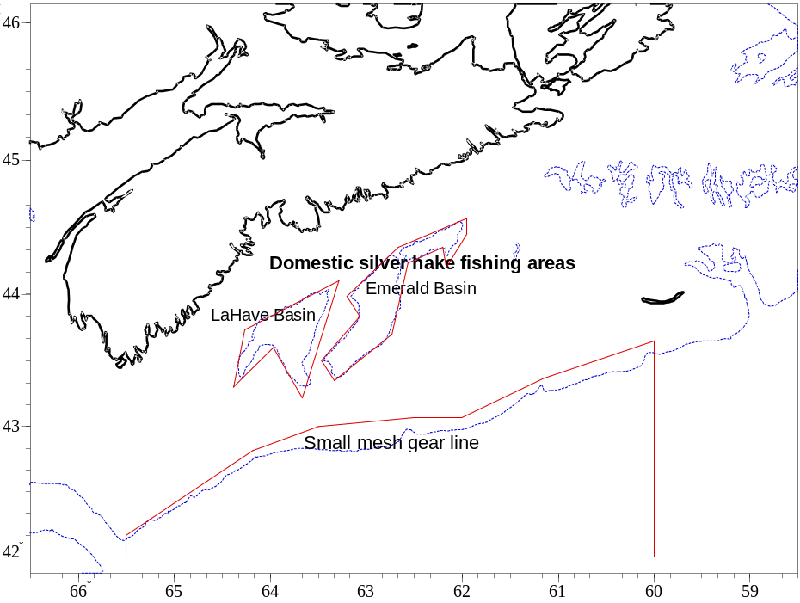
Figure 1: Scotian Shelf silver hake fishing areas.

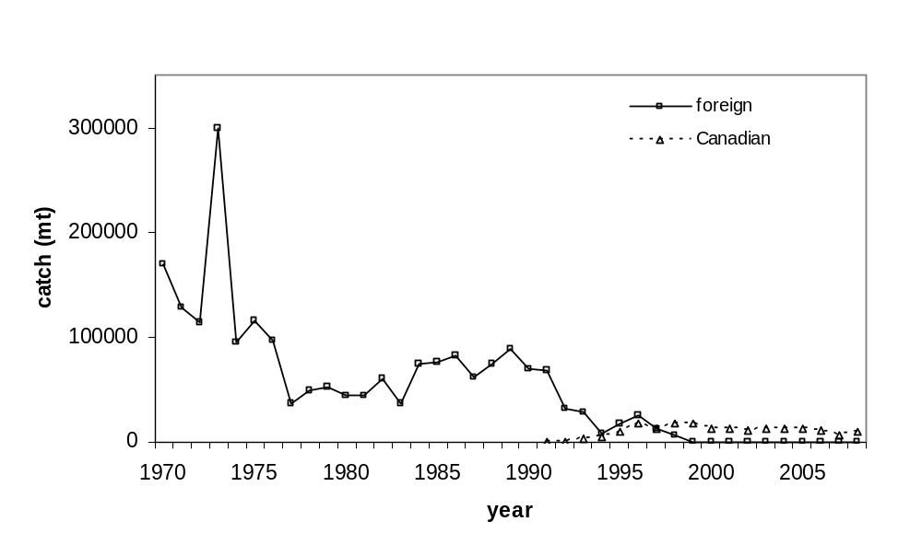

Figure 2: Historical catches of Scotian Shelf silver hake, 1970-2008.

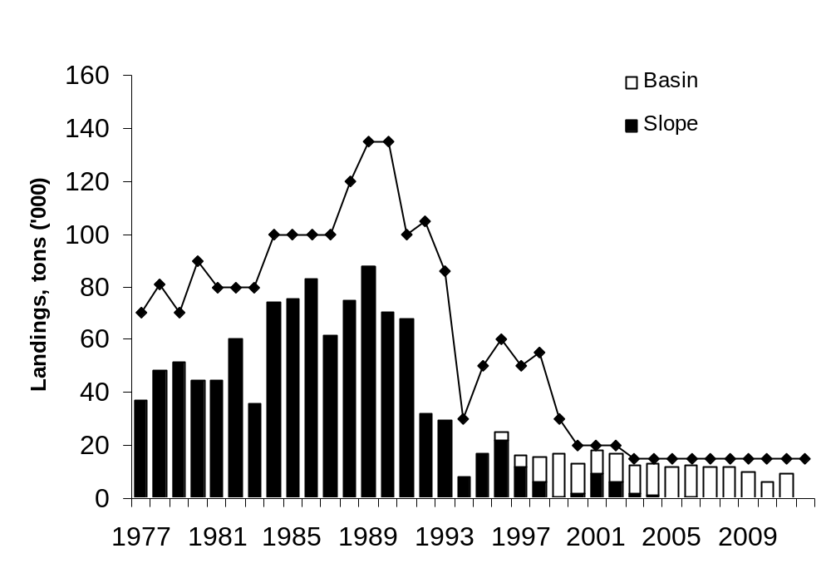
Figure 3: Silver hake TAC and catches by fishing area, 1979-2008.

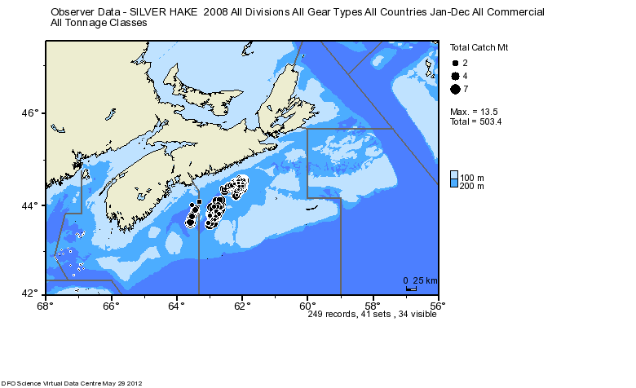
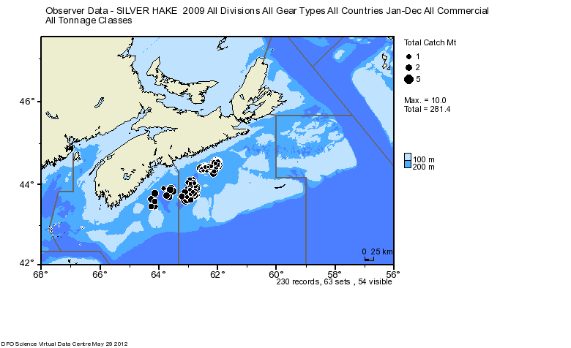

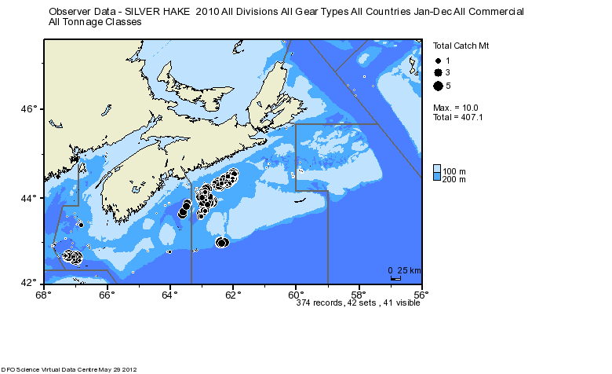

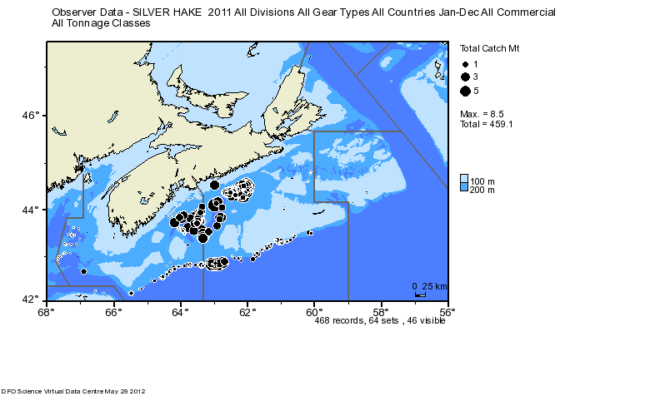
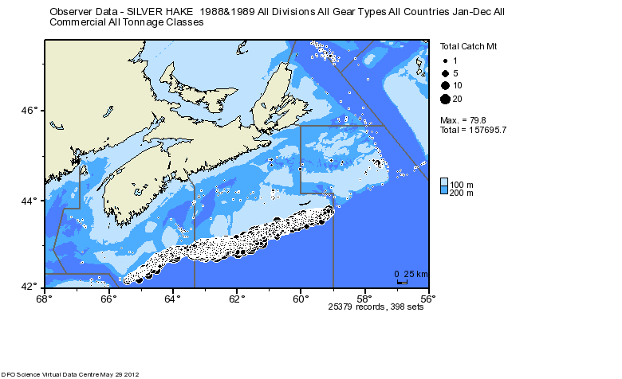

Figure 4: Recent catch locations by Canadian vessels 2008-2011, as well as an example of foreign fishing locations.

Appendix A: Results of age comparison between current year and previous years.

Ager1 (x) | 0 | 1 | 2 | 3 | 4 | 5 | 6 | 7 | 8 | 9 | 10 | Total
0 | 6 | 0 | 0 | 0 | 0 | 0 | 0 | 0 | 0 | 0 | 0 | 6
1 | 0 | 64 | 1 | 0 | 0 | 0 | 0 | 0 | 0 | 0 | 0 | 65
2 | 0 | 0 | 38 | 2 | 0 | 0 | 0 | 0 | 0 | 0 | 0 | 40
3 | 0 | 0 | 3 | 26 | 8 | 0 | 0 | 0 | 0 | 0 | 0 | 37
4 | 0 | 0 | 0 | 6 | 18 | 1 | 1 | 0 | 0 | 0 | 0 | 26
5 | 0 | 0 | 0 | 0 | 4 | 11 | 3 | 0 | 0 | 0 | 0 | 18
6 | 0 | 0 | 0 | 0 | 0 | 0 | 2 | 0 | 0 | 0 | 0 | 2
7 | 0 | 0 | 0 | 0 | 0 | 0 | 0 | 2 | 0 | 0 | 0 | 2
8 | 0 | 0 | 0 | 0 | 0 | 0 | 0 | 0 | 1 | 1 | 0 | 2
9 | 0 | 0 | 0 | 0 | 0 | 0 | 0 | 0 | 0 | 1 | 0 | 1
10 | 0 | 0 | 0 | 0 | 0 | 0 | 0 | 0 | 0 | 0 | 1 | 1
Total | 6 | 64 | 42 | 34 | 30 | 12 | 6 | 2 | 1 | 2 | 1 | 200

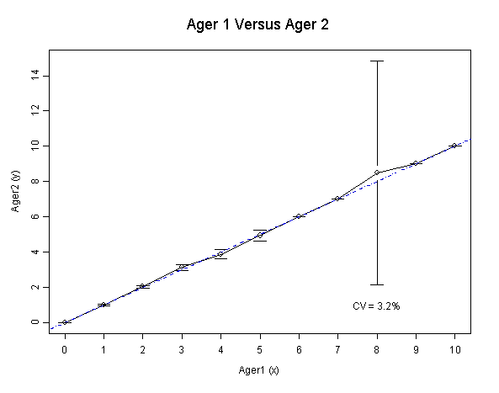
CATCH AT AGE

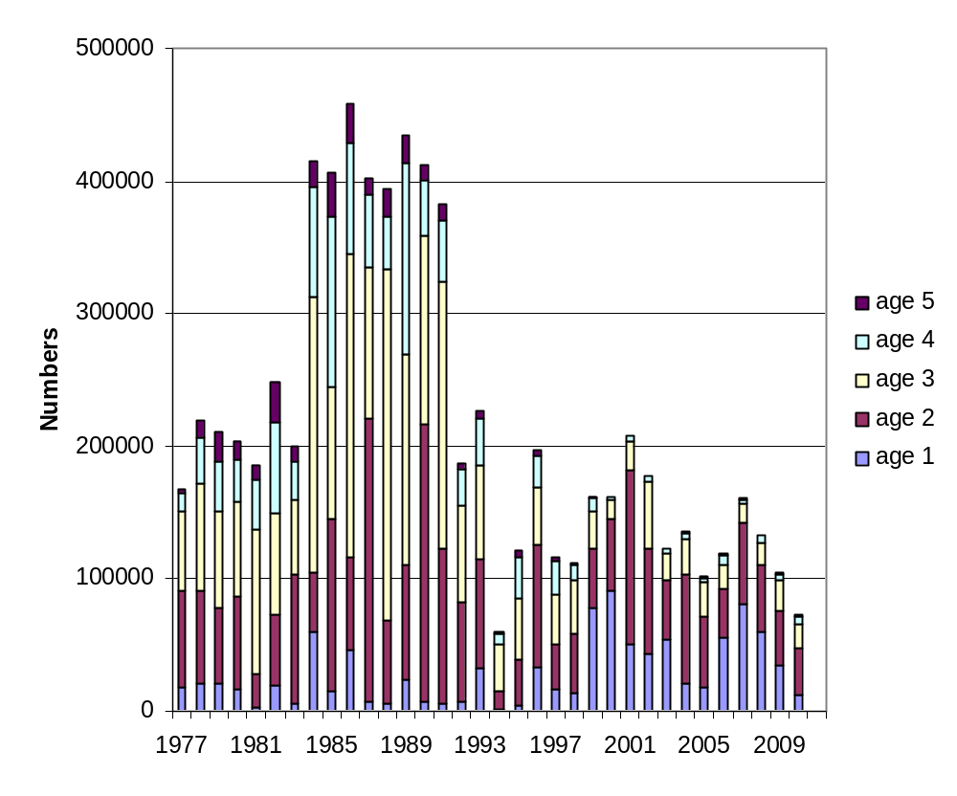
Figure 5: Silver hake catch at age comparison for all fleets, ages 1-5 from 1977 to 2011.

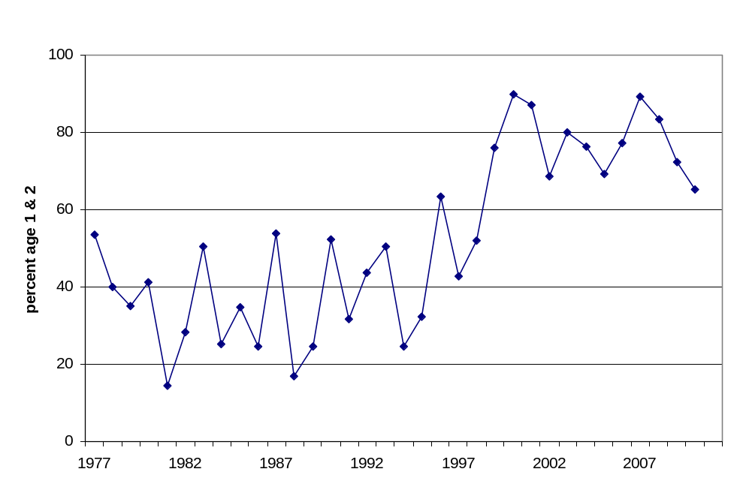
Figure 6: Silver hake catch at ages 1 and 2 as a proportion of the total catch, 1977 – 2008.

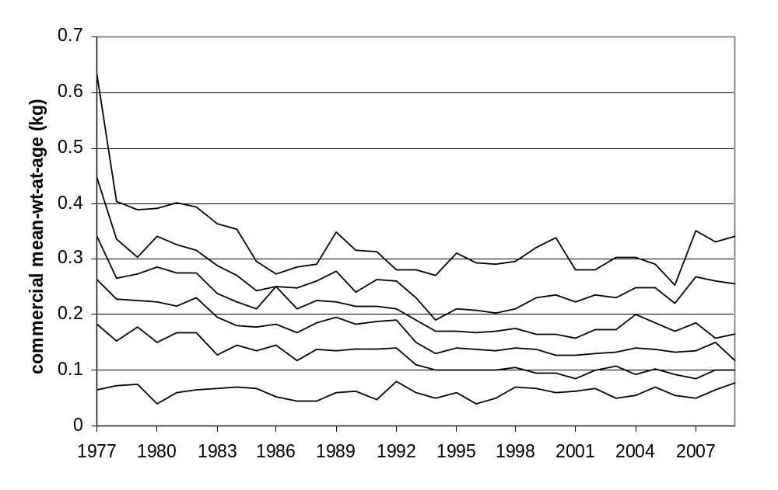
Figure 7: Silver hake weight-at-age comparison for all fleets, ages 2-6 from 1979 to 2008.

RV

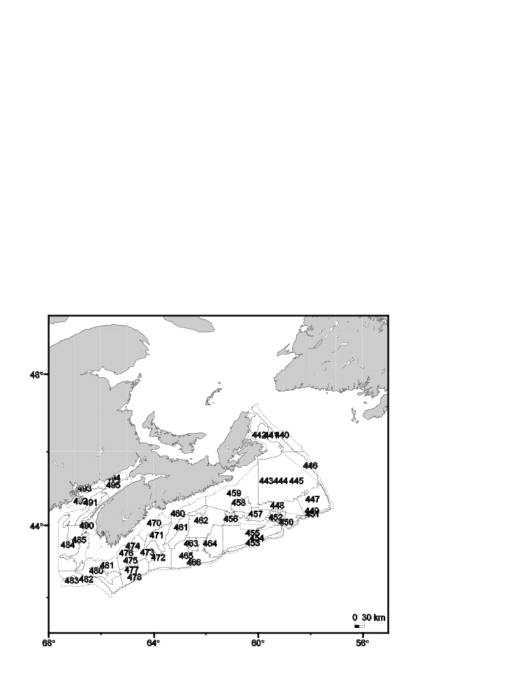
Figure 8: Stratification scheme for the Canadian July groundfish research vessel survey on the Scotian Shelf.

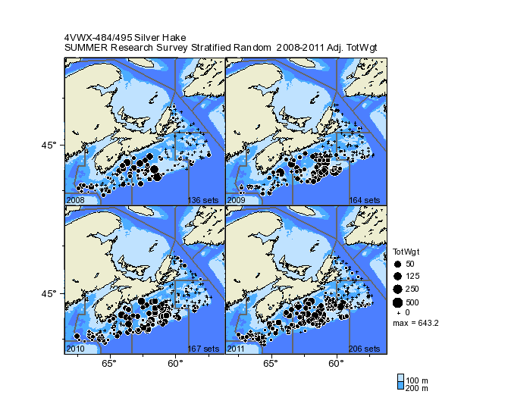
Figure 9: Sampling locations for the DFO summer research survey, 2008-2011
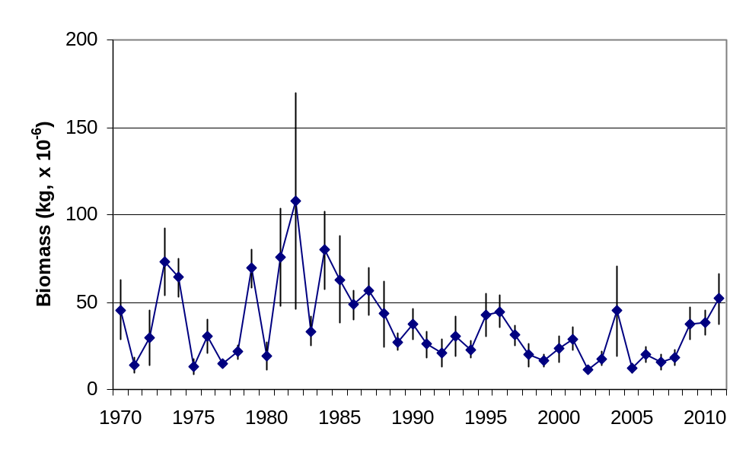

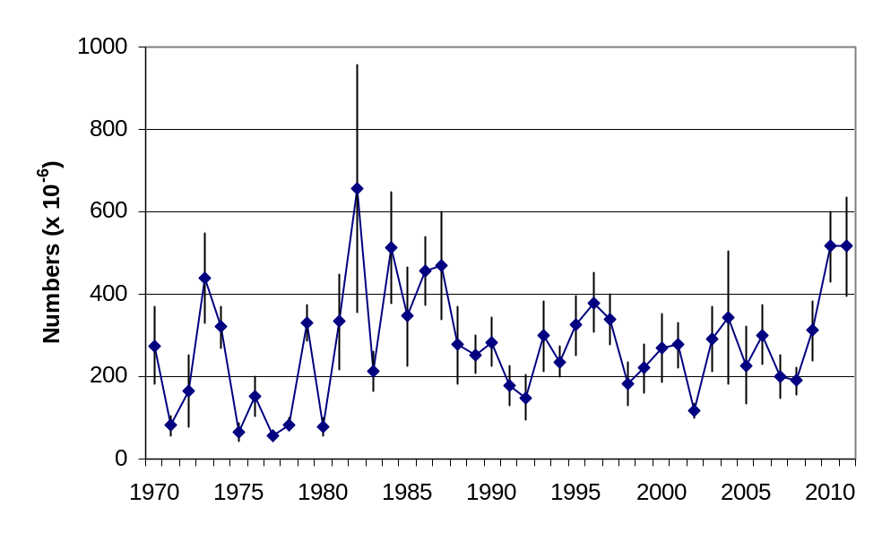
Figure 10: Silver hake biomass and abundance estimates from the Canadian July groundfish research vessel survey, 1970-2011, for Scotian Shelf strata 440-483 (excludes Bay of Fundy). Years 1970-1981 corrected for survey vessel effect.

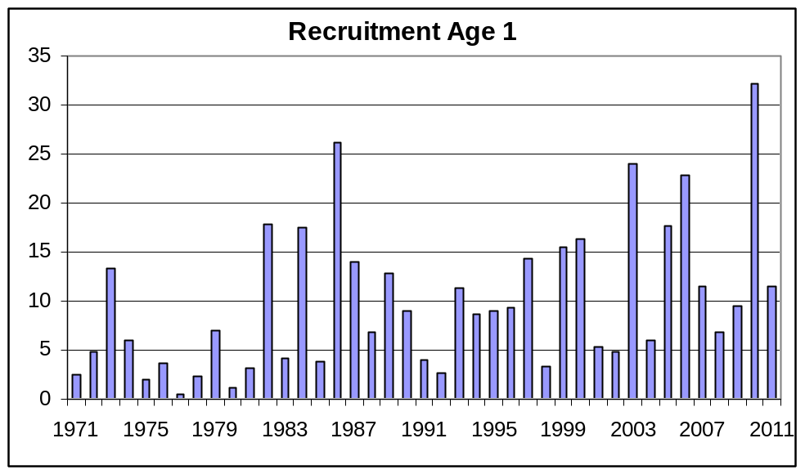
Figure 11: Recruitment estimates for Scotian Shelf silver hake from age 1 Canadian July groundfish research vessel survey

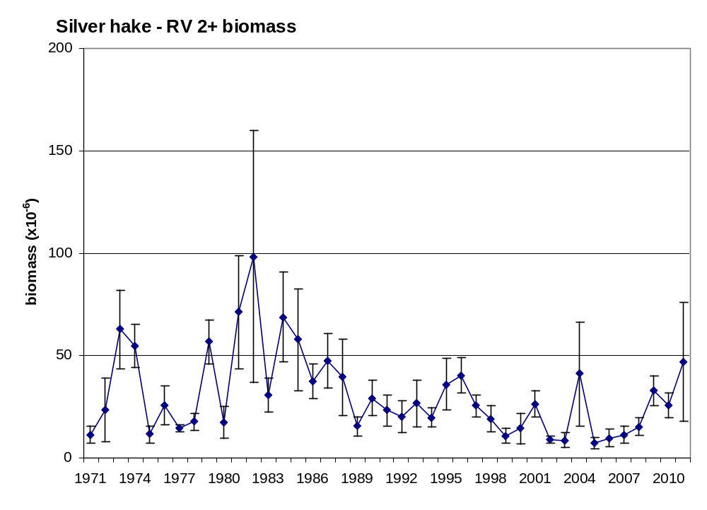
Figure 12: Silver hake age 2+ biomass (kg) from the Canadian July groundfish research vessel survey, 1971-2011.

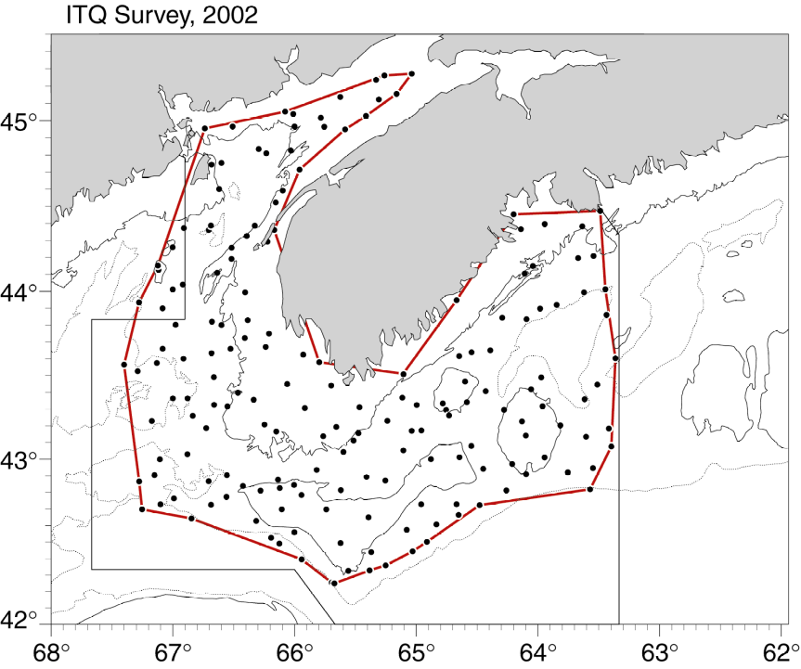
Figure 13: Distribution of fixed station locations in ITQ survey.

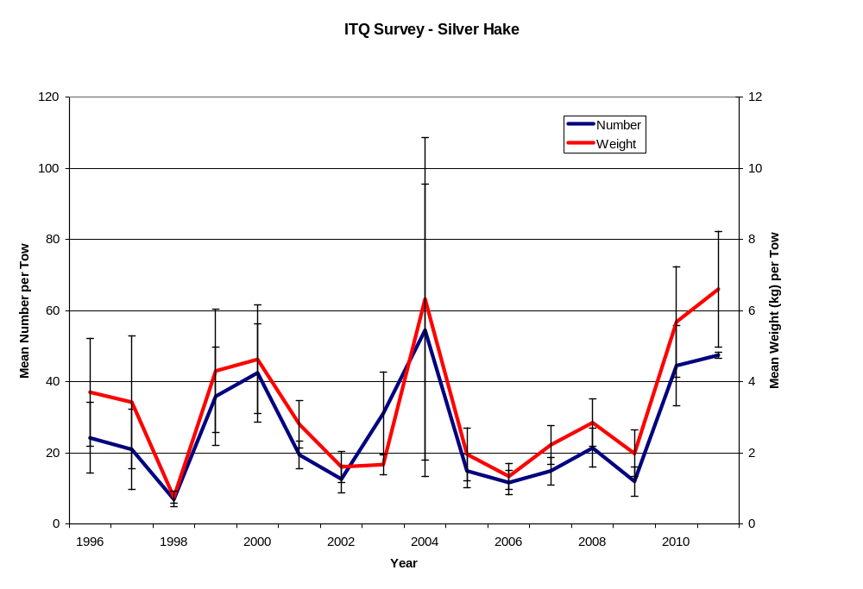
Figure 14: Silver hake abundance and biomass estimates from ITQ survey, 1996-2009, for Scotian Shelf strata 440-483 (excludes Bay of Fundy).

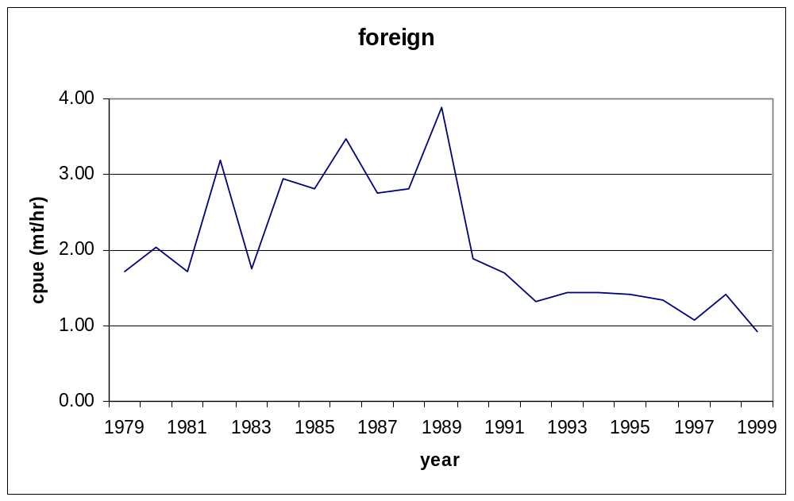
Figure 15: Predicted catch rates from the foreign fleet (tons/hour) for silver hake in NAFO Div. 4W, in July, 1979-1999.

.
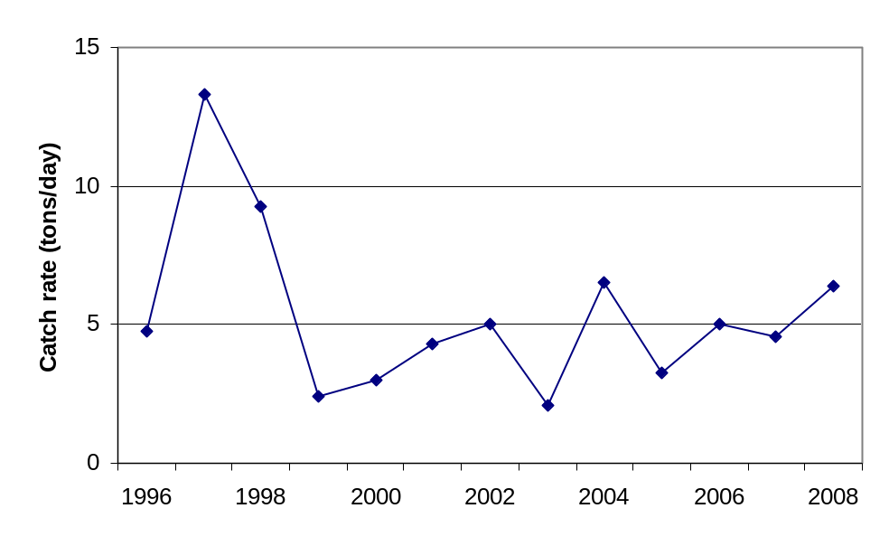
Figure 16: Predicted catch rates (tons/day) for silver hake in NAFO Div. 4W, in July, 1996-2008

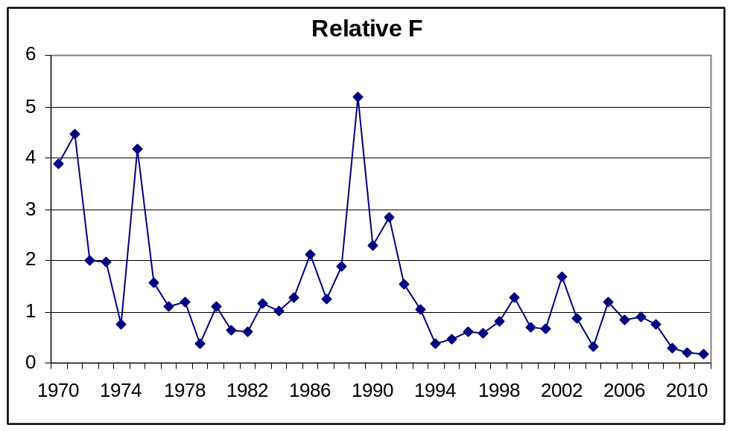
Figure 17: Relative F for Scotian Shelf silver hake from the Canadian July groundfish research vessel survey biomass and commercial catch weight, 1970–2011.

SPAWNING

Eggs (May to Oct.)

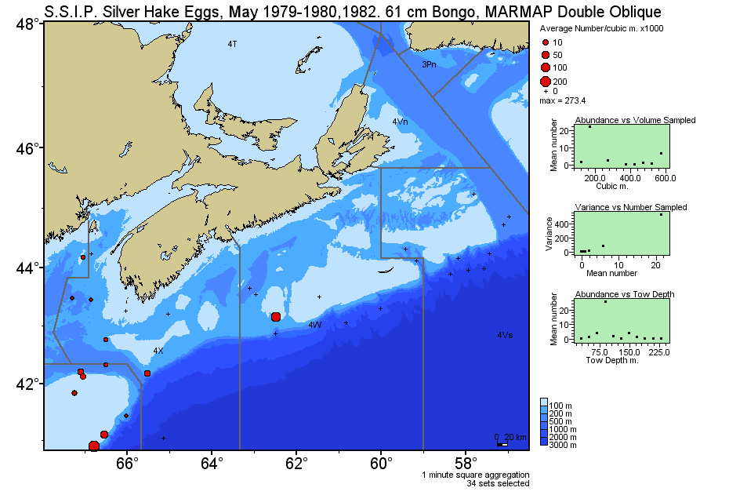

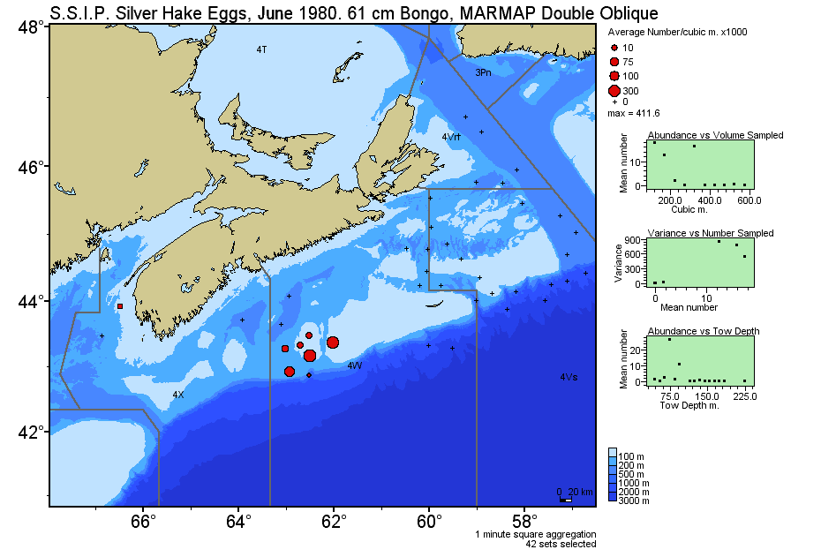

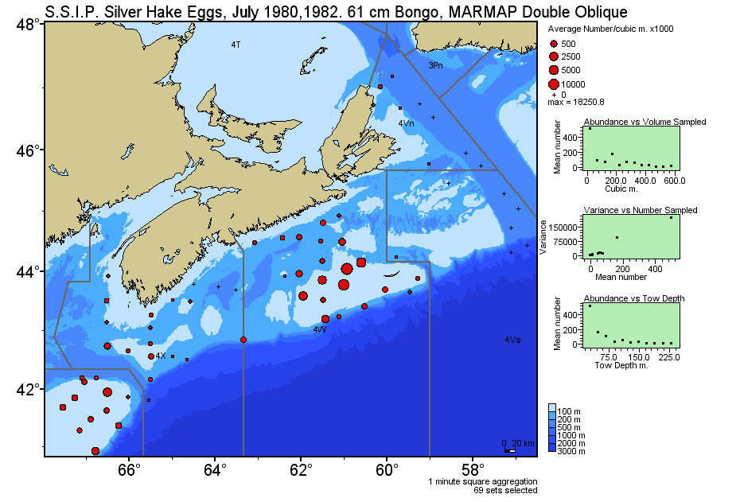

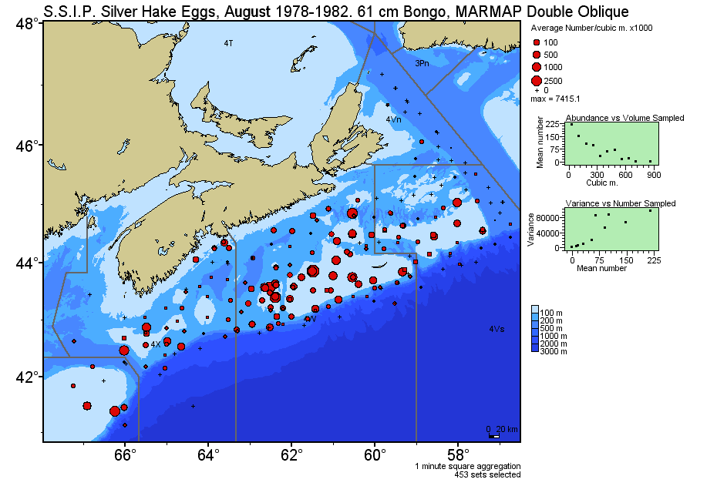

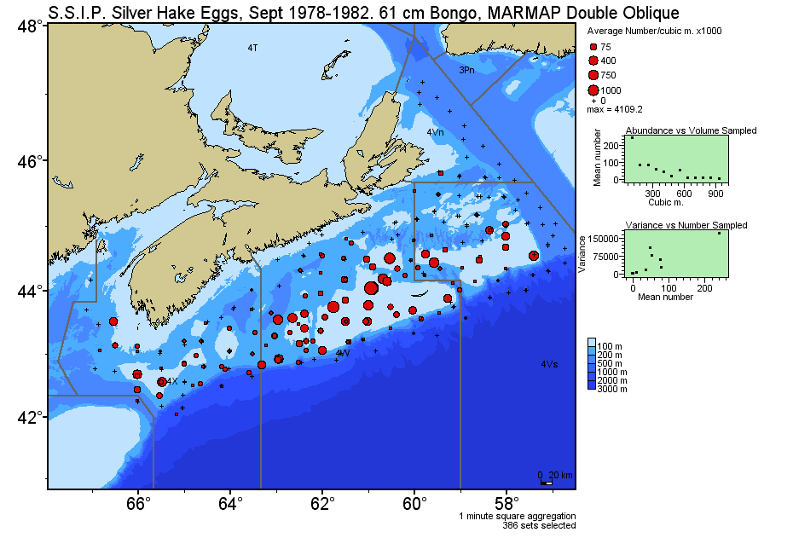

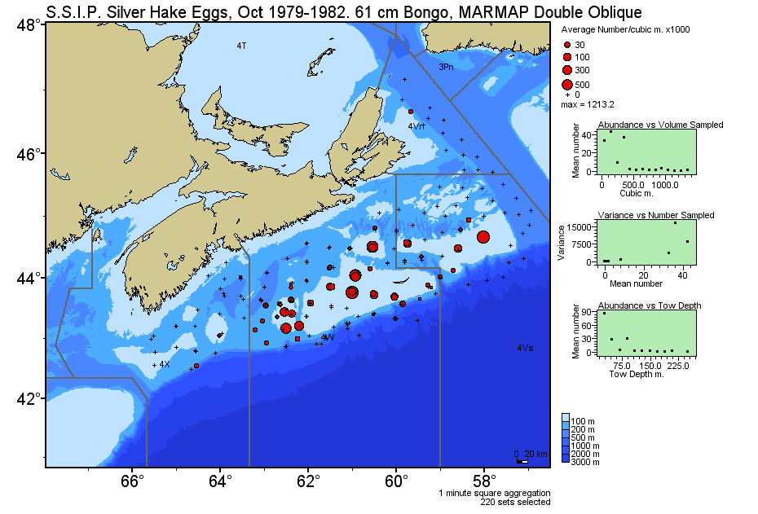
Figure 18: Abundance of silver hake eggs on the Scotian Shelf, 1980-1982, from SSIP surveys (pages 36 to 38)
Larvae (July to Nov.)

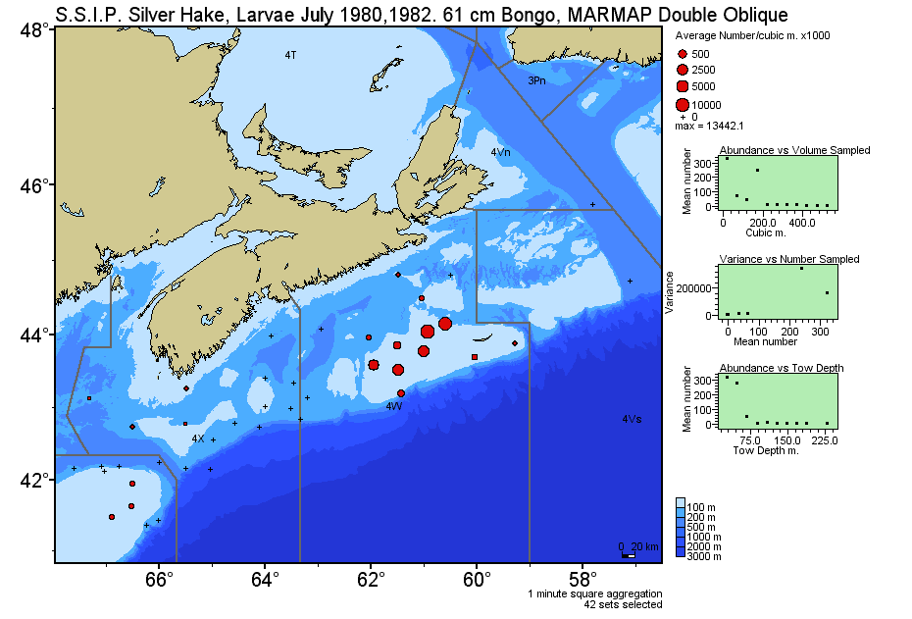
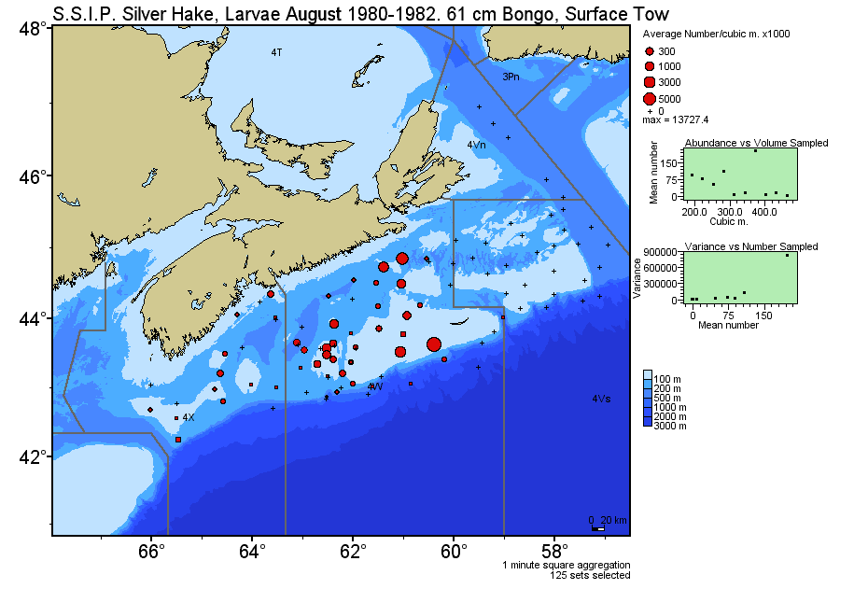

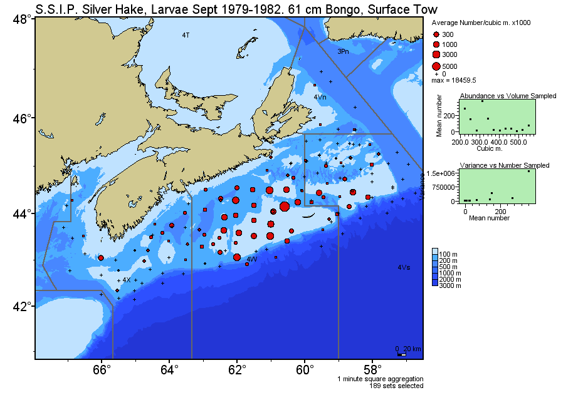
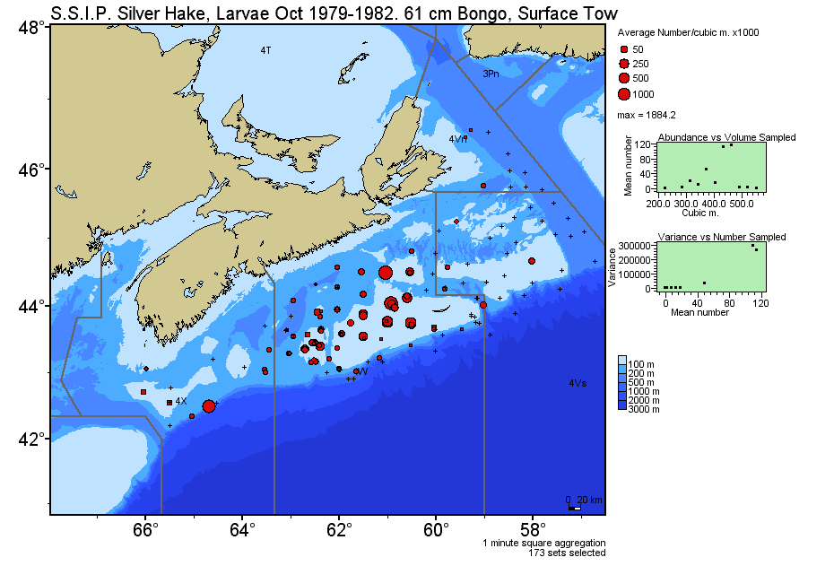
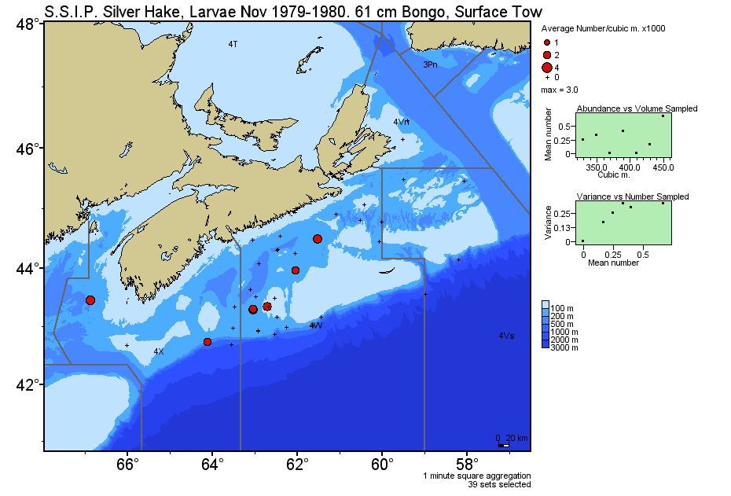
Figure 19: Abundance of silver hake larvae on the Scotian Shelf, 1980-1982, from SSIP surveys (pages 39 to 41)
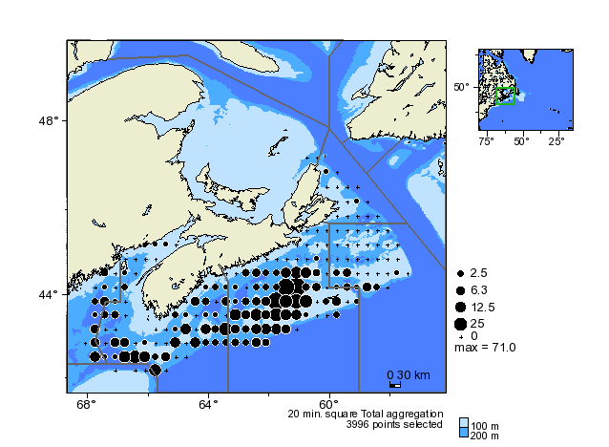
Figure 20: Ripe and running silver hake sample on th DFO summer RV survey, 1970-2011.

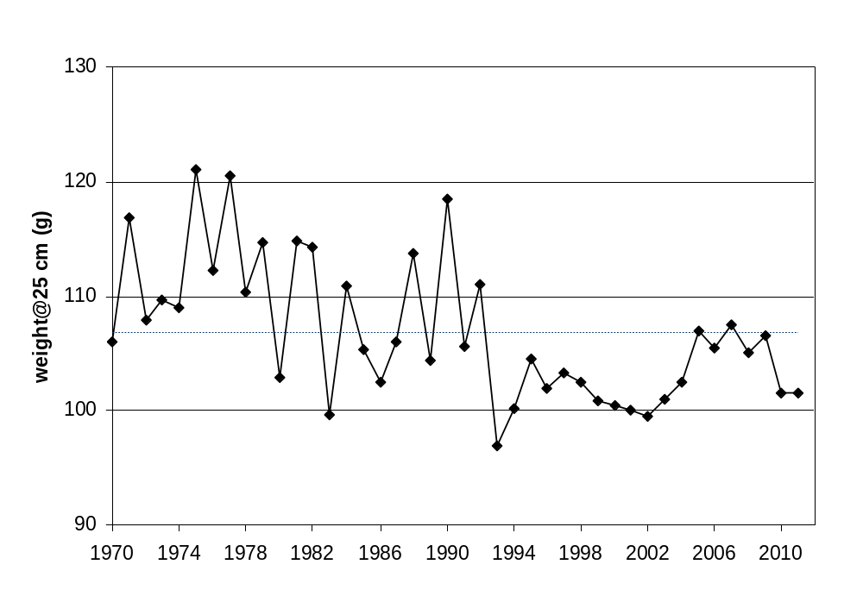
Figure 21: Condition factor (predicted weight at 25 cm) for Scotian Shelf silver hake from the Canadian July groundfish research vessel survey data (Note – dotted line is average for the time series).
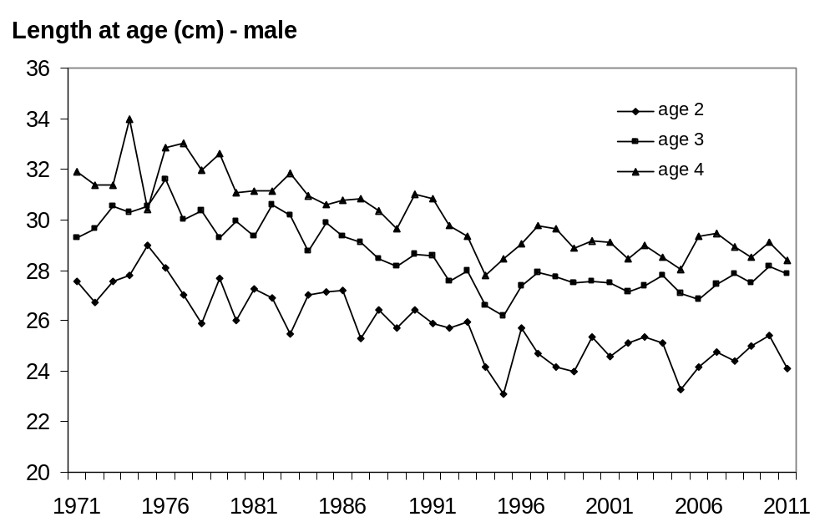
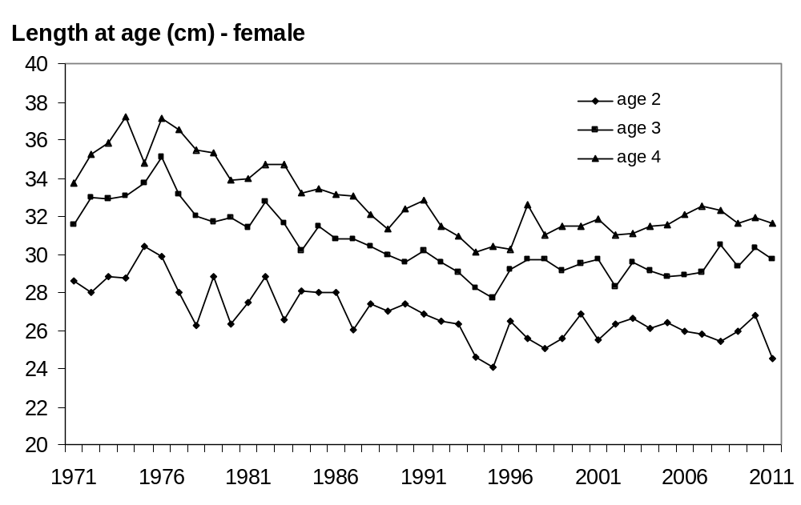

Figure 22: Mean length-at-age for Scotian Shelf silver hake from the Canadian July groundfish research vessel survey data, 1971-2008.

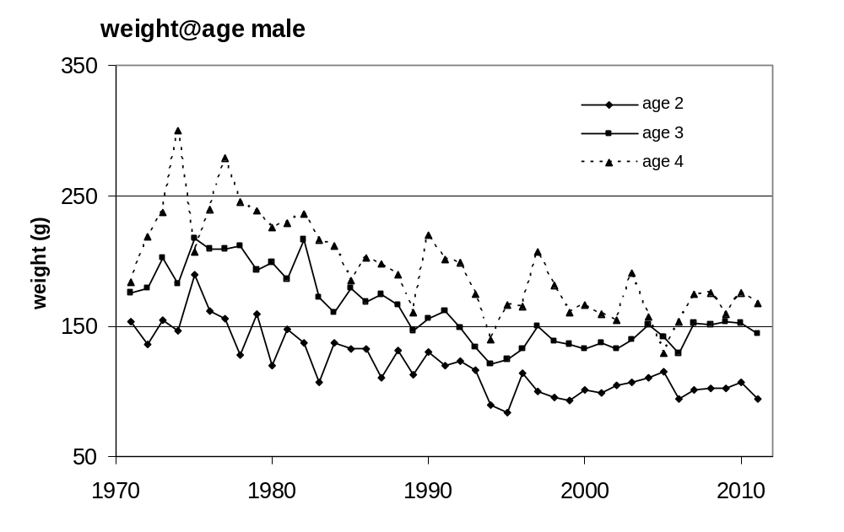
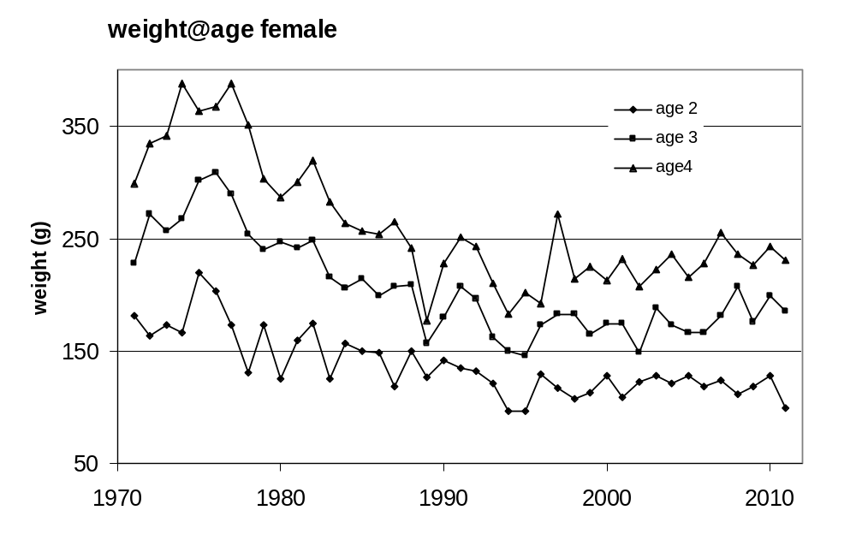
Figure 22: Mean wight-at-age for Scotian Shelf silver hake from the Canadian July groundfish research vessel survey data, 1971-2011.

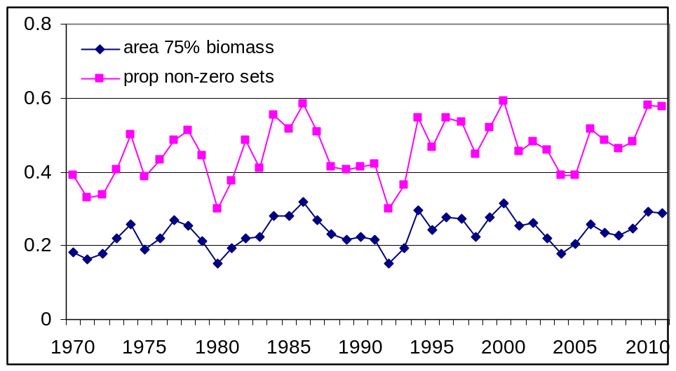
Figure 23: Indices of spatial distribution Scotian Shelf silver hake from the Canadian July groundfish research vessel survey, 1971-2009.

